Joe O’Regan, Sean Horgan, Brian Ryan

K00203642, K00196030, K00202212

Abstract

This report presents a full break-down and explanation into how our third-year team project, Antibody, was constructed. The main body will cover a class breakdown and in-depth explanation of their workings with UML diagrams and other figures that will aid in their explanation. All UML diagrams also have brief descriptions of each function and variable listed in the diagram to the right of each class figure.

Antibody

A Race Against Time to Save The Professor



|  |  |
| --- | --- |
| Title of Project | **AntiBody** |
| Student Name & Number: | Joe O’Regan K00203642 |
| Student Name & Number: | Brian Ryan K00202212 |
| Student Name & Number: | Sean Horgan K00196030 |
| Date | 3rd April 2017 |
| Word Count  (excluding appendices) | 14,563 |

Games Design and Development – BSc (Honours) in Computing (Level 8)

Limerick Institute of Technology (Tipperary)

Certificate of authorship

We hereby certify that this material, which we now submit for assessment on the programme of study leading to the award of Games Design and Development – BSc (Honours) in Computing is entirely our own work, and has not been taken for the work of others save and to the extent that such work has been cited and acknowledged within the text.

|  |  |
| --- | --- |
| Name of Candidate: | Joe O’Regan |
| Signature of Candidate: |  |

|  |  |
| --- | --- |
| Name of Candidate: | Sean Horgan |
| Signature of Candidate: |  |

|  |  |
| --- | --- |
| Name of Candidate: | Brian Ryan |
| Signature of Candidate: |  |

**Table of contents**

List of Figures 4

List of Tables 7

Acknowledgements 8

Abstract 9

1 Introduction 10

2 Problem Definition and Background 11

3 Literature Review and Research 17

4 System Design and Configuration 20

5 Example of use 65

6 Testing & Implementation 69

7 Critical analysis 79

8 Conclusions 84

9 Bibliography 89

10 References 90

11 Appendicies 92

11.1 Joe O’Regan Reflection 92

11.2 Sean Horgan Reflection 104

11.3 Brian Ryan Reflection 113

11.4 Test Cases 120

11.5 Game Installation 123

11.6 How to play 124

11.7 game controls 125

11.8 Team Charter 128

11.9 Original Feature List 131

11.10 PROJECT CODE DVD…………………………………………………………………….133

# List of Figures

|  |  |  |
| --- | --- | --- |
| **Number** | **Description** | **Page** |
| **Figure 1** | A light-hearted joke to get started… | 10 |
| **Figure 2** | Gantt chart overview | 14 |
| **Figure 3** | Gantt chart feature assignment breakdown | 15 |
| **Figure 4** | Audio class diagram | 20 |
| **Figure 5** | Blockage class diagram | 21 |
| **Figure 6** | Blockage texture | 22 |
| **Figure 7** | Blood cell class diagram | 22 |
| **Figure 8** | Large blood cell texture | 23 |
| **Figure 9** | White blood cell texture | 23 |
| **Figure 10** | Button class diagram | 24 |
| **Figure 11** | Collision class diagram | 25 |
| **Figure 12** | AABB collision detection diagrammatic explanation | 26 |
| **Figure 13** | Collision test case diagram | 27 |
| **Figure 14** | Types of enemy objects and their inheritance | 28 |
| **Figure 15** | Enemy boss class diagram | 28 |
| **Figure 16** | Enemy boss animation frames | 29 |
| **Figure 17** | Enemy ship class diagram | 30 |
| **Figure 18** | Nanobot enemy animation sprite sheet | 30 |
| **Figure 19** | Enemy virus class diagram | 30 |
| **Figure 20** | Green virus enemy animation sprite sheet | 31 |
| **Figure 21** | Orange virus enemy animation sprite sheet | 31 |
| **Figure 22** | Blue virus enemy animation sprite sheet | 31 |
| **Figure 23** | Enter name class diagram | 32 |
| **Figure 24** | Explosion class diagram | 32 |
| **Figure 25** | Explosion animation sprite sheet | 33 |
| **Figure 26** | Blood explosion animation sprite sheet | 33 |
| **Figure 27** | Modified blood explosion animation | 33 |
| **Figure 28** | Frames per second class diagram | 34 |
| **Figure 29** | Game class diagram part 1 | 36 |
| **Figure 30** | Game class diagram part 2 | 37 |
| **Figure 31** | Game loop diagram | 39 |
| **Figure 32** | Game Object class diagram part 1 | 41 |
| **Figure 33** | Game Object class diagram part 2 | 42 |
| **Figure 34** | Game Object class diagram part 3 | 43 |
| **Figure 35** | Abstract game object class diagram | 44 |
| **Figure 36** | High Scores class diagram | 45 |
| **Figure 37** | Heads Up Display screenshot | 45 |
| **Figure 38** | Professor map with blue ship indicators | 46 |
| **Figure 39** | Heads Up Display class diagram | 47 |
| **Figure 40** | Level Class diagram | 48 |
| **Figure 41** | Main menu with random background image | 48 |
| **Figure 42** | Main Menu class diagram | 49 |
| **Figure 43** | Particle Class diagram | 50 |
| **Figure 44** | Random particles from player ship and rocket | 50 |
| **Figure 45** | Player class diagram | 51 |
| **Figure 46** | Power up class diagram | 53 |
| **Figure 47** | Various power ups available in-game. | 53 |
| **Figure 48** | Score Value Text class diagram | 54 |
| **Figure 49** | Scrolling background class diagram | 55 |
| **Figure 50** | Three background images used in each level | 55 |
| **Figure 51** | Settings menu class diagram | 56 |
| **Figure 52** | Settings menu screenshot | 56 |
| **Figure 53** | Splash screen class diagram | 57 |
| **Figure 54** | Status bar class diagram | 58 |
| **Figure 55** | Texture class diagram | 59 |
| **Figure 56** | Abstract weapon class diagram | 61 |
| **Figure 57** | Weapon types and their inheritance | 61 |
| **Figure 58** | Enemy laser weapon class diagram | 62 |
| **Figure 59** | Player laser weapon class diagram | 62 |
| **Figure 60** | Player ninja star weapon class diagram | 63 |
| **Figure 61** | Player rocket weapon class diagram | 63 |
| **Figure 62** | Player rocket weapon class diagram | 64 |
| **Figure 63** | Use case version 1 diagram | 65 |
| **Figure 64** | Player controls use case diagram | 66 |
| **Figure 65** | Player/Menu interaction use case diagram | 66 |
| **Figure 66** | Main Menu Sequence Diagram | 67 |
| **Figure 67** | Game Play Sequence Diagram | 68 |
| **Figure 68** | Orange virus spawning not working as it should | 69 |
| **Figure 69** | Tracking down memory leak | 70 |
| **Figure 70** | Testing blue virus | 71 |
| **Figure 71** | Rendering life power up for testing purposes | 72 |
| **Figure 72** | Testing information messages | 73 |
| **Figure 73** | Testing speed boost timer on HUD | 73 |
| **Figure 74** | Testing enemy boss movement | 74 |
| **Figure 75** | Race Mode with distance indicator, and ghost ships indicating the distance between players | 77 |
| **Figure 76** | Code snippet of Mix_Chunks and fucntions for all effects | 82 |
| **Figure 77** | Code snippet separate function for each effect | 83 |
| **Figure 78** | Final implementation of playFX() function | 83 |
| **Figure 79** | Collision testing of player cutting through blockage | 120 |
| **Figure 80** | Collision testing of player flashing when hitting static object | 121 |
| **Figure 81** | Timer testing, timer flashing when time is about to run out | 121 |
| **Figure 82** | Background testing, background stops scrolling after certain time | 122 |
| **Figure 83** | Important note about SDL include folder | 123 |
| **Figure 84** | Keyboard control layout | 125 |
| **Figure 85** | Button layout for Nvidia Shield layout | 127 |
| **Figure 86** | What each button does | 127 |

# List of Tables

|  |  |  |
| --- | --- | --- |
| **Number** | **Description** | **Page** |
| 1 | Project Scope Objectives | 12 |
| 2 | Components, Milestones and Deadline Dates | 16 |
| 3 | Expected Project Deliverables | 16 |
| 4 | Modifiable features in TestData.h header file | 78 |
| 5 | Rendering Improvements | 80 |
| 6 | Player 1 Keyboard Controls | 125 |
| 7 | Player 2 Keyboard Controls | 126 |
| 8 | Other Game Keys | 126 |

# Acknowledgements

Without the Beginning Game Programming V2.0 by Lazy Foo Productions it would have been extremely hard to create this game with SDL or otherwise. A lot of the art work used in the game was provided by Indre Macernyte. An audio track was also contributed by Jim O’Regan who also provided a brief tutorial in how to use Guitar Pro to enable the creation of a further 2 original tracks.

Further inspiration was taken from SDL Game Development by Shaun Mitchell, and Game Programming Patterns by Robert Nystrom. Unfortunately, time didn’t allow for the implementation of some of the great ideas in these books.

# Abstract

AntiBody is a 2D Side-scrolling computer game, programmed in Visual Studio 2015 in C++ using the SDL library. It is a race against the clock, battling past enemies to complete each level, and save you friend the professor’s life.

This report presents a full break-down and explanation into how our third-year team project, Antibody, was constructed. The main body will cover a class breakdown and in-depth explanation of their workings with UML diagrams and other figures that will aid in their explanation.

# Introduction

The project documentation laid out in the coming pages is a detailed description of the work undertaken throughout the duration of this project. It will be a complete descriptive account of what has been made, and how it has been made. The processes involved in creating this piece of work and the processes involved in making sure this piece of work is up to an acceptable standard. We will show where we believe we have succeeded and where we have failed. We also would like to demonstrate our ability to create a piece of software, to a high standard, that we would be happy releasing to the public. This project uses C++ and SDL:

* C++ is a general-purpose programming language. It has imperative, object oriented and generic programming features, while also providing facilities for low-level memory manipulation.
* We decided as a group that we would utilize a 3rd party extension library called SDL. Simple Direct Media Layer is a cross-platform development library designed to provide low level access to audio, keyboard, mouse, joy-stick, and graphics hardware via OpenGL and Direct3D.

We did a lot of work, so there’s a lot of explaining, which means a lot of reading (**Figure_1**).



Figure Despite all the typing we can still see the funny side, despite all the blisters on our fingers

# Problem Definition and Background

The project goal was to create a racing game using C++ and the SDL libraries. This was to be completed without the use of a game maker or game engine to assist. All programming needed to be completed by ourselves. We had to design and develop this game from the ground up, using the skills and knowledge acquired to date whilst also learning new concepts or technologies. This involved a lot of planning, research and collaborative work together as a group.

The Scope Statement is an essential part of this or any project and it will be used to outline the results the project will produce and the terms \ conditions under which the work will be performed.

* Project Justification
* Project Objectives

**Project Scope Justification**

This is a group project that we must complete as part of year 3 in our Bachelor’s degree. It is a group based project which we will complete as part of a team of 3. It will enable us to show many different skills, such as team work, project coordination, programming, designing, and other skills.

|  |
| --- |
| **Table 1: Project Scope Objectives** |
| Create a racing game which we can enter in Games Fleadh 2017, and complete this game to a high standard which we can use for our third-year project module. |
| The game should have at least 3 levels |
| Our game will include time trial like stages, with objects and enemies trying to slow the player down which will increase the sense of speed and pressure the player feels to try and hit the next checkpoint |
| The player must focus on more than one activity at a time adding to the challenge |
| Measure our games completeness by the number of completed features on the features list |
| A realistic level of success will be reached if we can complete 75% of the features we have laid out beginning with the highest priority |
| We have a strict hand up date for Games Fleadh and our project deadline, all code needs to be completed in advance of this deadline to enable us to test the game and it’s features thoroughly |

**Key Tasks**

The key tasks we identified were the features of the game that needed to be implemented and figuring out how to carry them out, by first researching and then coding the features.

The original features list (on next page) placed the game physics on the bottom of the list. Initially, this kind of put us off a bit, but the more research we did, the more straightforward it seemed. The features list was updated as the game progressed, and so the Gantt chart also needed to be updated as we adjusted our planning as we learned what features were important, and which of the features were reliant on other features.

**Features list**

1. **Movement**: Player must be able to move throughout the levels. Control

initially by keyboard.

**Sub feature:** Add game controller, or steering wheel input

1. **Perspective**: Top down perspective

**3. Enemy Spawning**: Enemies can spawn at random points, or fixed points depending on the situation, level or stage of the level

**4. Player Weapons**: Player must be able to shoot enemies

**5. Power Ups:** Player can get power ups (speed, defense, attack, alternate

weapons)

**6. Collision:** Collision detection, contact detection

**7. Sound**: Add music, sound effects

**8. Graphics**: Sprites, backgrounds, and background layers for parallax, other

objects

**9. Timer**: Countdown clock, checkpoints, or time-stages

**10. Background:** Parallax Movement

**11. Personality**: Different player sprite (vehicle, car, ship), different colours representing different personalities, same for enemies, e.g. Pac-man

**12. Levels**: Adding difficulty as levels progress, increased number of and additional enemies. Different and less frequent power ups. Different objectives. Different backgrounds, and scenery. Alter the perspective, maybe change from top-down to side-view

**13. User interface**: Scores, time, menu, map, hints, dialogue, lives, health, weapons, inventory

**14. Enemy**: Implement a variety of enemies, some that are visible on screen at the same time, and some that only appear in the game at different stages, such as end of level bosses

**15. AI**: Artificial Intelligence for computer controlled enemy to race

**16. Multiplayer**: 2nd player to race against, one player representing the hero, the other the enemy, or a rival team

**17. Network Play**: Play multiplayer over a network

**18**. **Game Physics:** Force, velocity, torque, increase / decrease object speed.

**Project Plan**

We have our proposed schedule mapped out in Gantt chart form (**Figure_2**) assigning both time and team members to individual features (**Figure_3**). This allowed us to plan so we are always working on 3 features at a time, as we felt this was the best approach to begin with, until we learned which features would require the most attention.

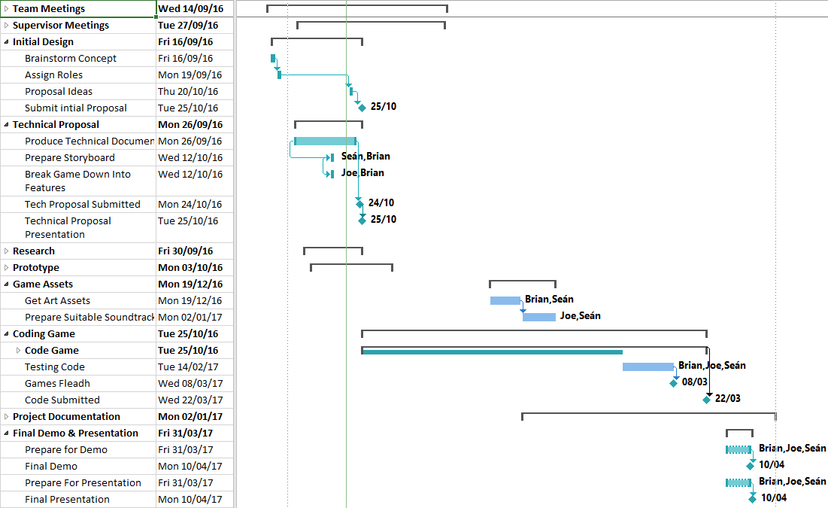

Figure Gantt Chart Overview

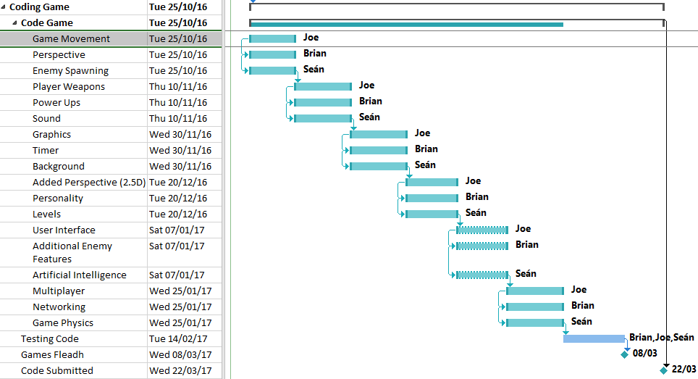

Figure Gantt Cart Feature Assignment Breakdown

As part of the project we also had several documents to compile, presentations to give, and deadlines to meet as a team, and an individual team assessment (**Tables 2 & 3**). This required a lot of organisation and coordination.

|  |  |
| --- | --- |
| **Table 2: Components, Milestones and Deadline Dates** | |
| Initial Project Proposal Submit | 25th of September 2016 |
| Initial Proposal Accepted | 30th of September 2016 |
| Formal Technical Proposal Submit | 24th of October 2016 |
| Project Proposal Presentation | 24th of October 2016 |
| Individual Team Assessment | 14th of January 2017 |
| Interim Project Demonstration | 25th of January 2017 |
| Games Fleadh | 8th of March 2017 |
| Code Submitted | 22nd of March 2017 |
| Hard Copy Project Demo | 3rd of April 2017 |
| Final Presentation | 4th of April 2017 |

|  |
| --- |
| **Table 3: Expected Project Deliverables** |
| Initial Project Proposal |
| Formal Project Proposal |
| Technical Document |
| Presentation on Technical Document |
| Team Management CA to be completed |
| Code for completed game |
| Project documentation |
| Demonstration and showcase of game |

# Literature Review and Research

**Initial Research**

Originally, we decided that it would be best if we each studied and researched a different area of game development languages, and then we could report our findings back to the group, and discuss what we thought were the benefits and drawbacks of each. Joe decided to research Cocos 2dx which is a multi-platform extension library for C++, Sean researched Java in game development to see if we could build a game using Java, and Brian researched SDL, an extension library for C++.

Our research consisted of video tutorials, written tutorials and books that we found on the internet. We carried out lots of research and studied many different vendors of tutorials. We programmed along with the video tutorials and we compiled many different programs to see what we could come up with during this research and evaluation period.

After our research period was over we came back together and divulged our results to each other. We discussed every video series we watched and books we had studied. We weighed up the pros and cons for each different programming paradigm that we had been studying.

We decided to use SDL and C++ for the project due to the research period being very fruitful and garnering lots of resources for SDL. There was in fact a lot more readily available resources to help us and aid us in the challenge that lay ahead. We decided against using Cocos 2dx for a couple of reasons, mainly being the lack of learning resources available to us. Java game development was a novel idea and many games are created using Java but the game we imagined and the features we imagined would be best built using C++ and SDL.

**SDL Research**

After deciding on C++ and SDL we compiled a feature list, and we split the features evenly among ourselves, setting 2 weeks to research each individual feature to find out how it could be implemented. Not every feature took the full 2 weeks, and the easy to follow structure of the Lazy Foo tutorials allowed us to get a number of tutorials done and in some cases, all of the tutorials, giving us all a good base to begin working on the project.

Using the SDL tutorials, we could get a prototype with movement and scrolling background ready for the first presentation. This helped us to get across our vision for the game, and what we hoped to achieve in our proposal presentation.

**Books**

As part of the course we studied books like “Beginning C++ Through Game Programming” (Dawson, 2010). This book outlined the concepts used in object oriented programming such as polymorphism and abstraction, and how they could be applied to digital game programming.

As part of our continuous assessment in the Digital Game Programming Principles and Practice module, we created a text based adventure game which helped us understand the concept of classes and other object oriented techniques and how they are implemented in games and software in general. The book was a big help in understanding these concepts.

In the Advanced Digital Game Programming module, the book “SDL Game Development” (Mitchell, 2013) introduced us to more advanced C++ game programming. We had already done quite a bit of research and programming on the game by then, but to get a look at more advanced ways of doing things with class separation and different methods of handling textures for graphics, and state machines gave us a lot of ideas to bring to our game.

We also studied “Game Programming Patterns” (Nystrom, 2009) where we looked at game patterns. There are many simple patterns such as the game loop that we had already implemented in games without maybe realising these were in fact programming patterns. While we didn’t get the simple state machine fully finished as the features started to pile up in the game, the benefits of implementing a finite state machine form the beginning were not lost on us, and this is a lesson learned going forward.

**Tutorials**

The main online tutorials we learned from, were the “Beginning Game Programming v2.0” (Lazy Foo’ Production) series of tutorials specific to SDL game programming. These tutorials helped us get a prototype game up and running extremely quickly. The tutorials give all the basic features of a game in small units, which we could study and use as inspiration to create features in the game, based on what we now knew to be possible.

Other tutorials we looked at include the TwinklebearDev SDL 2.0 Tutorials (Will Usher, 2013) and countless YouTube videos, not to mention the time we put into researching C++ itself on tutorials point and cplusplus.com, Unity, Java, and Cocos 2d-x. All the other development platforms we looked at had positives and negatives, with Cocos 2d-x having great cross platform capabilities, armed with the knowledge we have now especially with C++ attempting to use it again would not be the hard task it first was.

**In Class**

What we learned in class and during our continuous assessment in both Digital Game Programming Principles and Practice and Advanced Digital Game Programming went a long way towards helping us understand object-oriented programming and its concepts. We could take the basic game creation aspects from the simple text game we created in the earlier module and apply them to our game. Concepts such as the game loop, and classes which weren’t covered in the main tutorials we followed.

# System Design and Configuration

**Audio (Audio.h and Audio.cpp)**

The audio class (**Figure_4**) uses a singleton pattern so only one instance of the class is used in the game, s_pInstance, for this the constructor and destructor are both private. An integer *currentSong* is used to store the current songs *listOfMusic* array position. The sound effects are stored using a map m_sfxs, and the music is stored in a vector listOfMusic.

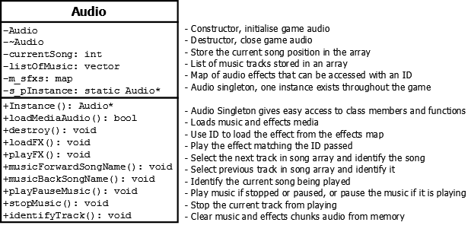

Figure Audio Class

**Functions**

The loadMediaAudio() function loads the music using details from the arrMusic array and stores it in the listOfMusic vector, it also loads the sound effects using the path details in the arrSoundEffects array, and adds them to m_sfxs. Details stored in the arrays for music and sound effects include the path, ID, and error message to display if the effect/track fails to load. The media can be loaded using a for loop.

The loadFX() function loads sound effects. Sound effects are accessed in the game using the playFX() function, this uses an id string to load the required effect from the map.

Audio tracks can be skipped forwards and backwards, using the ‘k’ and ‘l’ keys on the keyboard and the trigger buttons on the gamepad. When a track skips identifyTrack() is called and it displays on screen the track details including: song name, title, and song artist for our original soundtrack.

The music can be started, paused/played using playPauseMusic(). This displays an information message on the game screen indicating if the music is paused or played, and calls identifyTrack() to display the track information. MixPlayingMusic() is used to detect if music is playing. Mix_PlayMusic() is used to play the track, and the number of times to loop can be set. MixPausedMusic(), Mix_ResumeMusic(), Mix_PauseMusic() are used to identify if the music paused or not and the resume or pause the music.

The stopMusic() function stops the music by calling Mix_HaltMusic(), it also displays an information message indicating the music has stopped when in game mode.

The destroy() function is used to clear the map of sound effects and vector of songs from memory.

**Blockage (Blockage.h)**

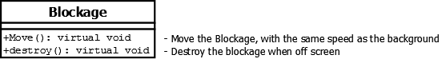

Figure Blockage Class

The Blockage (**Figures_5_&_6**) is a sub-type of the Enemy base class. To fit into the game environment, the blockage object represents cholesterol clogging the vein which the player must cut through to proceed along the level. The cholesterol blockage moves from the right most side of the screen to the left at the same scroll speed as the background until it is off the screen, which leads to it being removed from memory.

**Functions:**

move() handles movement by setting the object’s velocity to the scroll-speed of the background. Four blockage objects spawn in a vertical line to give the impression that they are all one big wall, with no way for the player to navigate around them, the player is forced to think about the tools available to them, and work out a way to go through it.

The player needs to activate the saw weapon to cut through the blockage, otherwise it will push the player off-screen to their demise. The blockage has very simple behaviours, yet poses a significant threat to the player if they don’t pay attention. The intention for this obstacle is create a more dynamic gameplay experience, forcing the player to multi-task. This dynamic adds a further level of difficulty to the game, and when implemented to a balanced version of the game, helps when attempting to balance the difficulty scaling between levels.



Figure Blockage texture

**Blood Cells (BloodCell.h and BloodCell.cpp)**

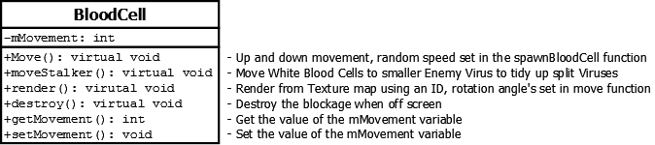

Figure Blood Cell Class

There are three types of blood cell in the game small, large, and white blood cells. Blood Cells are a sub-type of Enemy but they were meant to be more of an obstruction, with the Large Blood Cells acting as more of an obstacle to the Player pushing them back, a little bit like asteroids in a space game.



Figure Large and small Blood Cells have similar textures

Small Blood cells move in the background and do not affect the player in any way. They are merely part of the furniture, highlighting the fact the Player Ship is within a blood vessel. Large blood cells (**Figure_8**) can be split by player weapons causing an explosion of blood splattered on the screen. The White Blood Cell (**Figure_9**) does not interfere with the player in any way, but when a player splits an enemy virus in two, the white blood cell can then swoop in to clear up the virus, as they are a more manageable size for the white blood cells to break down.



Figure White Blood Cell texture

The constructor for Blood Cells takes an integer sub-type variable, this decides the type of blood cell to be created. Each type has a unique name, texture ID, angle or rotation, and dimensions. A random rotation direction is selected for each blood cell clockwise or anti-clockwise, and a random speed with a range of 1 to 3, using the spawnRandomAttributes() function of Game class.

**Functions**

Blood cells have up and down, and rotating movement, the amount to move up and down, and rotation angle is updated in move(). Different spinning speeds allow large blood cells to move slower than the others. White Blood Cells have stalker movement, moving to the position of the nearest small virus when if there is one, otherwise it rolls across the screen like tumbleweed. The angle of rotation when drawing to screen and the direction to rotate is applied in render(). The object is checked to see if it is active on screen with GameObjects destroy() function and set not alive if not.

**Buttons (Button.h and Button.cpp)**

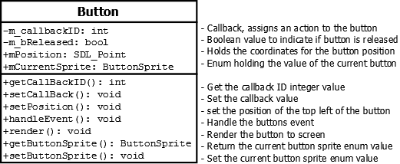

Figure Button Class

The button class handles the button interactions within the game menus. Main menu, high score and settings. We have the call back ID which assigns an action to each button. There is a Boolean value being set to show us whether the button has been released. We set the position of the buttons using SDL_Point, which is a structure for defining a 2D point. We need to render the text for each button and we must handle the sprite enum for each button.

**Functions**

Obviously, because this is a button class we need to handle events; we handle mouse events in this class. Is the mouse moving, is the mouse button down or is the mouse button up? In the event handler class, we check if the mouse is inside the area of the button if not we set the relevant sprite enum, if so then we go to our switch statements checking each case and each button and we carry out the relevant action required.

Putting all the button functionality into this class was good use of OO programming and allowed us to minimise the code being used and saved us from having to repeat a lot of code in the program.

**Collisions (Collision.h)**

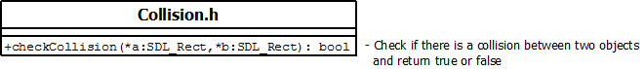

Figure Collision Class

The collision class contains the function for checking if there is a collision between two objects, checkCollision(). The checkCollision() function reads in two SDL_Rect objects as parameters and compares all sides of the both objects for an intersection between them.

This method is called **AABB Bounding Box Collision Detection**. An object will receive an SDL_Rect bounding volume on creation of the object, which sizes itself to fit exactly around the dimensions of that object. This bounding volume’s position maps directly to the (X, Y) coordinates of the object it is assigned to, which means that the volume will follow the object everywhere it goes, always encompassing the object. Every tick/game update, the game objects are checked for collisions between each other, on example would be that the Player Ship will be checked against enemy objects, power up objects, and obstacles.

When collisions are detected the objects are updated, destroyed or other events triggered depending on both types of objects. If a player collides with a power up, it is added to his inventory or adds to its health. If a player collides with an Enemy his health is reduced or the enemy is destroyed depending on the weapon the player has active. Ninja Stars can split Blood Cells but lasers have no effect. Collisions can lead to many different outcomes, so it solely depends on the objects involved.

There are many ways of handling collisions, including using collision layers and different shaped collision boxes such as circular collision detection. For our game using rectangles as collision boxes suited our needs.

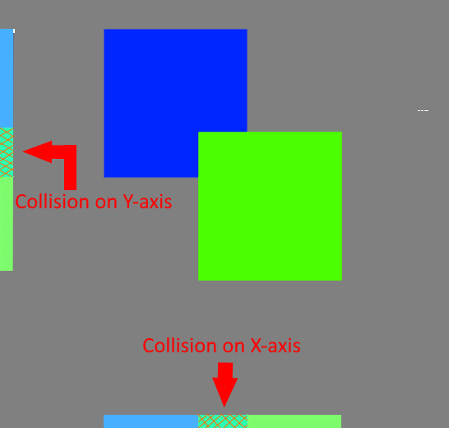

Figure AABB Bounding Box Collision on both X and Y axis result in the function returning true

How this collision checking works is, two individual SDL_Rect objects will be passed into the checkCollision() function (**SDL_Rect *a** and **SDL_Rect *b**), for example, the bounding volume for the Player Ship (*a) and Enemy Ship (*b). These two SDL_Rect objects will be given an X and Y value depending on which side of the volume it is, the left and right sides are given and X coordinate value and the top and bottom sides are given and Y coordinate value.

These values are the X-min/max and Y-min/max values. All the sides of volume **\*a** are then compared to see if they are outside of volume **\*b**. If they are outside volume **\*b** they are not intersecting and there is no collision, the function will return false. If any side of **\*a** is inside **\*b** then they are intersecting at some point and there is a collision, this means that the X-min/max and Y-min/max are colliding on both axes (**Figure_12_&_13**). The function will return true and any consequences of the collision will be handled in the if statement that called the checkCollision() function.

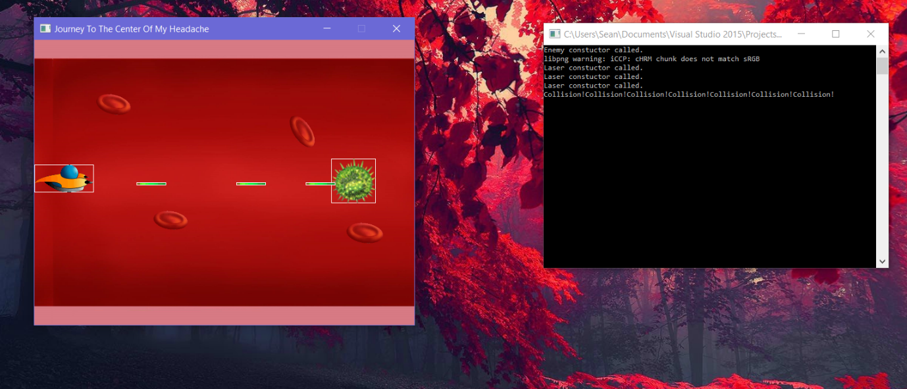

Figure Test Case where player-laser collision is being checked against an enemy virus, note the white boxes around the player, lasers and virus, which are the bounding volumes for each object.

**Enemy (Enemy.h)**

Enemy base class inherits from Game Object (**Figure_14**). There are 5 different Enemy sub-classes, EnememyShip, EnemyVirus, EnemyBoss, Blockage and BloodCell. This class has no functionality and is a template class for Enemies in the game. Game Objects have a type and sub-type to be used to filter them on the game objects list.

The base class also acted as a type for classifying the types of objects, making it easier to check collisions for several objects at a time, and move and update several objects together the same way, as all Enemies move from right to left and the player moves left to right onscreen.

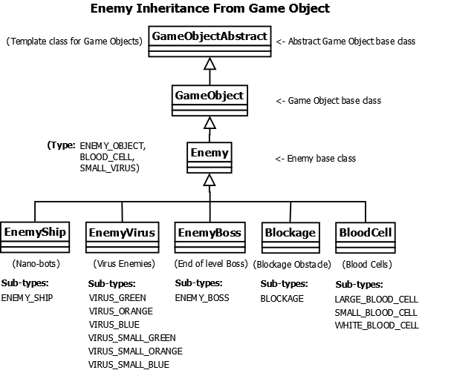

Figure Types of Enemy objects

**Enemy Boss (EnemyBoss.h)**

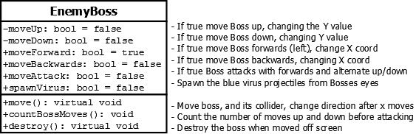

Figure Enemy Boss Class

The Boss (**Figure_15**) is a sub-type of Enemy but with more functionality than basic Nano-bots and Viruses. It has more varied movement than other enemy objects, but stops short of the start of the game screen when moving, giving the player a position from which to attack. It also fires lasers from its eyes and viruses from its mouth in level 1.



Figure Enemy Boss animation sprite sheet based on Lorcan

The boss moves up and down on the same position before advancing right to left with up and down movement, after moving up and down 6 times in the same spot. The Boss spawns Orange Virus enemies as it moves backwards from its mouth. Lasers are spawned from its eyes after the laser spawning animation is finished.

**Functions**

In move() the collider is set with smaller dimensions than the Boss texture, so contact appears more realistic. A series of checks test if the Boss is moving forwards, backwards, up, down, or attacking. When the boss is retreating he spawns Virus enemies from his mouth. If the position of the boss is less than 200 pixels when attacking it moves back, and when it reaches the width of the screen on its X coordinate it moves forwards again.

The number of up and down moves when the boss initially approaches is counted in countBossMoves(), after 6 it attacks. It uses GameObjects destroy() function, and we didn’t get to create a render() function as the eye laser spawning is dependent on the eye spawning animation, so this is handled in Game.

**Enemy Ship / Nano-bots (EnemyShip.h)**

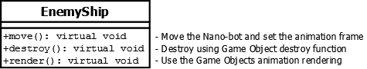

Figure Enemy Ship Class

The enemy ship or Nano-bot (**Figure_17**) moves right to left across the screen, firing intermittently based on its x-coordinate position, and the distance between shots. Nano-bots have one dimensional movement, inherited from the Game Object base class.

The animation for the enemy ship is rendered using the inherited Game Object render animation function using the stored ID for the sprite sheet texture (**Figure_18**).



Figure Nano-bot (Enemy Ship) animation sprite sheet

**Enemy Virus (EnemyVirus.h and EnemyVirus.cpp)**

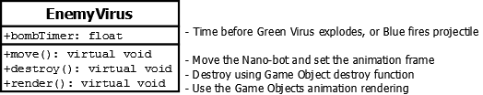

Figure Enemy Virus Class

There are three types of virus (**Figure_19**) Green, Orange, and Blue. The Green Virus (**Figure_20**) can move towards the player’s Y position on the screen, while the player is in front of them as they move right to left.



Figure Green Virus animation sprite sheet

The other two virus types have the same movement. Orange Viruses (**Figure_21**) have a countdown timer, and explode sending 8 fireballs in 8 different directions. The Blue Virus (**Figure_22**) type has a satellite object that fires when its timer runs out, and can spawn another virus when the timer resets.



Figure Orange Virus animation sprite sheet

Virus objects can be split in two by the players Saw and Ninja Star weapons. When they are split into a smaller size, the viruses can by terminated by the White Blood Cells which quickly move towards them to clean them up.



Figure 22 Blue Virus animation sprite sheet

**Functions**

In move() an information message warning of the Viruses approach is generated. The Viruses move in on the Players Y position while on the positive side of the players X coordinate. The collider moves with the texture, the destroy function is also called in move which is a mistake that wasn’t fully corrected throughout the game. The destroy functions were to be called in one loop in Game destroyGameObjects() function. The textures is rendered using GameObjects renderAnimation function, to handle the glowing animation of the virus textures.

**Enter Name (EnterName.h and EnterName.cpp)**

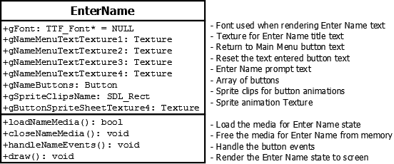

Figure Enter Name

The Enter Name state (**Figure_23**) was to be used to enter the Players names at the beginning of the game to enter and store a name for a Player to be used throughout the game and for the High Scores table. As there is an overhead with text input, and the game requires keyboard input for player movement, a separate state would have been necessary.

**Explosion (Explosion.h)**

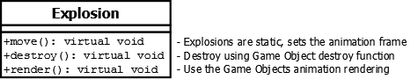

Figure Explosion Class

This class handles explosions (**Figure_24**) after collisions between objects and weapons. Different explosions are rendered for blood cells, the different types of Virus, and player and enemy ship collisions (**Figure_25**). Explosions are independently animated, so they don't show the same frame for every explosion appearing on screen, and the explosions start and end at different times.



Figure Explosion animation sprite sheet



Figure Vicente Molina Blood Explosion animation sprite sheet

The blood explosions (**Figure_26**) were downloaded from Vicente Molina’s website, and the colour is adjusted to render a different coloured splatter type explosion for Virus enemies such as the Blue Virus (**Figure_27**).



Figure Modified Blood Explosion animation sprite sheet for virus animations

**Functions**

The explosion class handles the animation frame in move() and uses inherited renderAnimation() function from GameObject to draw the textures to screen. The type of explosion is handled with the constructor’s sub-type attribute when instantiating an explosion. The constructor also takes the coordinates for where it is to be rendered.

**Frames Per Second (FPS.h and FPS.cpp)**

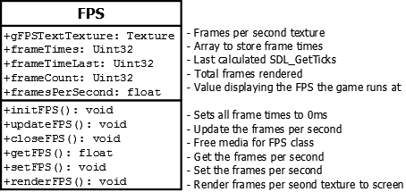

Figure Frames Per Second Class

Frames per second is displayed in the game by pressing the F1 key. The FPS class allows for the displaying of an accurate reading of frames per second that the game is running at. It is useful for debugging and spotting if there any problems within the game while its running. Usually if a group of objects are not being deleted properly then you might notice the FPS of the game beginning to drop when more and more objects pile on top of each other but don’t get deleted.

FPS is calculated by measuring how long each frame takes to render by using the SDL_GetTicks() function which returns an unsigned 32-bit value representing the number of milliseconds since the library was initialized. SDL_GetTicks() is called before rendering each frame, then the time is calculated by subtracting the value provided with the last value. The problem with this is that it can give us inconsistent readings, as stated in the example provided in the SDL Documentation Wiki. (Link to reference about SDL Wiki in references section). A better way of getting a more accurate reading is by averaging out the last few values by storing then in an array (frametimes [FRAME_VALUES] ).

**Initializing**

The fpsinit() function will get called once upon start-up. It will set all of the frame times to 0ms and set the last frame time to 0ms also. This initializes all variables used in the class to calculate and average FPS reading.

**Calculating an average FPS**

The current time is saved in *getticks,* the current frame time is the calculated by subtracting the frame time and then storing the result in the *frametimes* array. The frame count index for the array is incremented. All values stored in the array and then added all up and divided to get an average frame time (or frames per second reading). This value will be hard to understand if given to a user as it will be in millisecond, therefore it is divided by 1000.f to convert it into seconds, this value is then rendered to the screen as the current FPS that the game is running at.

**Rendering the FPS value to the screen**

The rendFPS() function reads in a string, *fpsText* which is used to render the current FPS to a texture on the games user interface on the screen. The texture is then rendered to the screen with a given position in the game window to be displayed, this position is fixed as it is a UI element.

**Game (Game.h and Game.cpp)**

The Game class (**Figure_29_&_30**) controls the initialisation, updating, and cleaning of the game. Object movement, rendering and functionality is handled within this class. Level progression and game over conditions are handles. A simple state machine controls progression from menu, and then through the levels, and back to the menu on game over. The game loops from within the update function.

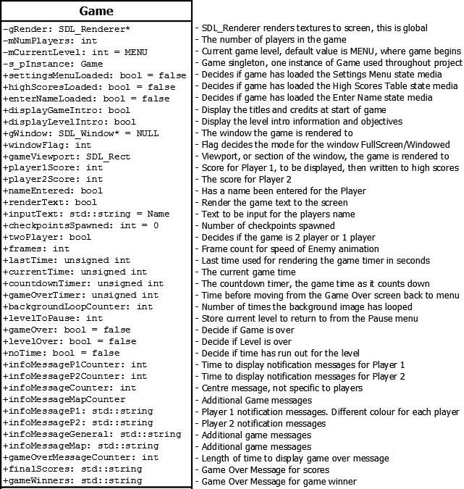

Figure Game Class Part 1

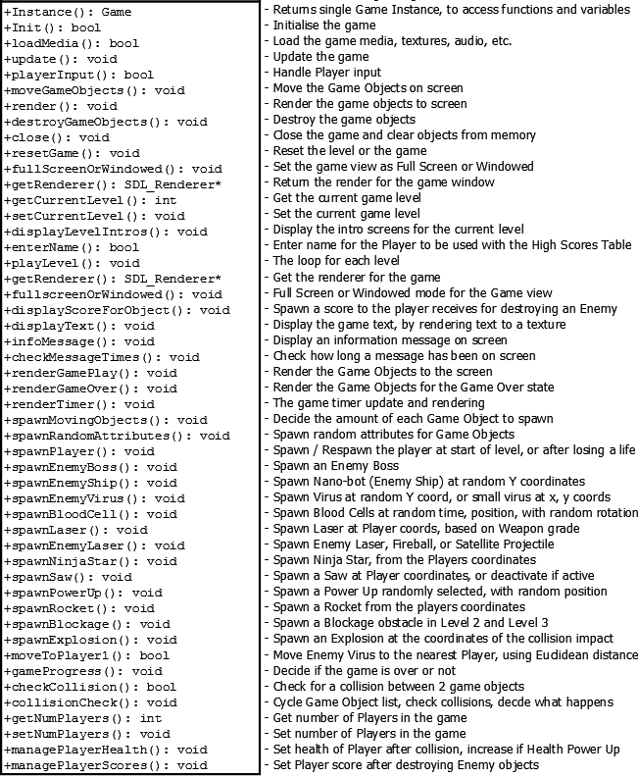

Figure Game Class Part 2

**Initialising**

The init() function initialises game, it first calls the resetGame() function setting the game variables for the current level, adding the Player and ScrollingBackground objects to the object list. SDL_Init() is called to initialise the libraries used in the game (video, audio, joystick, and haptic) and this must be called before any SDL functionality can be used.

The game controllers are initialised and the haptic force feedback support. Information about gamepads connected to the game has been separated to the Gamepad.h header file.

The main game window is initialised with a flag set for full screen or windowed, the default value is windowed. The window gWindow and renderer gRenderer are initialised, only one window is used in the game and the renderer is accessed throughout the game using the Game Instance Singleton when rendering textures.

SDL supports bitmap images by default, but to use other formats such as PNG they must be initialised with IMG_Init(). True Type Fonts must also be initialised with TTF_Init() to render text to the screen, using a wide variety of font type. In AntiBody, we mostly use a retro style font, to give the game a classic arcade game feel. Other fonts were tried and replaced due to readability and consistency issues.

Audio is initialised using Mix_OpenAudio(), the volume can be set using Mix_Volume(). The volume ranges between 1 and 128, the game is initialised to use the maximum volume of 128 with MIX_MAX_VOLUME. The Audio class handles loading of the original music soundtrack, and the sound effects used in AntiBody.

**Load Media**

The loadMedia() function is used to load the games media. The load media functions for the other classes are called here. This loads image files for textures, and animation sprite sheets. It separates the sprite sheets into its animation frame clips.

With the game being small we could get away with loading all the media for all elements of the game. With a larger game and with the use of a more advance state mechanism the loading of media and the managing of memory could have been handled a lot better. Media for each state of the game could be loaded as and when it was needed and not as a whole, and then freed from memory when the game advances to a separate state. The fonts are initialised, and the text for the game is rendered to a texture.

**Clear Media**

The close() function frees the textures, game controller, haptic controller, window, renderer, and the SDL subsystems from memory when the game is finished. This could also have been handled better with a better state machine. The media such as textures could have been freed when the states changed, instead of staying in memory for the full game.

**Update**

The update function checks the game is initialised and the media loaded before polling events for the gamepad, to check if a gamepad is connected and displaying its information. The game then loops (**Figure_31**) checking the states before spawning, moving, and checking collisions within the game.

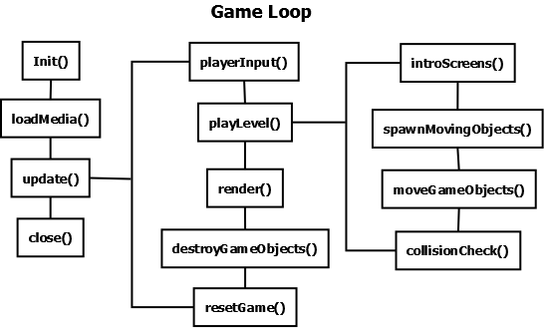

Figure Game Loop used in Game update function

**Input**

Input is handled in the playerInput() function in game, keyboard controls for audio, the game window, the map, and displaying the FPS are handled here, while Player Ship movement is handled in the Player class, and Rocket weapon movement is handled in the weapon base class. An input handler class would have been a better solution, but we didn’t have time to implement it.

**Levels**

If story mode is selected from the main menu, the game starts with intro screens with information about enemies, power ups, level objectives, and the story behind the game.

The spawnMovingObjects() function handles the amount of enemies to be present on the screen at any given time in each level. It also decides which enemies and boss are generated in each level. Virus enemies don’t all exist in all the levels, with Orange Exploding Viruses only introduced at the end of level one, when spawned by the end of level Boss, and then to be introduced in level 2, along with Blockage obstacles. Blue Viruses were to have a similar origin in level 2, and then continuing into level 3, with the spawnEnemyVirus() function having the capability to spawn Virus Enemies randomly each time it’s called.

The objects are moved around the screen and updated in moveGameObjects(), collisionCheck() handles collisions between objects and the outcome of these collisions.

The objects are then drawn to screen in the render() function.

The destroyGameObjects() function removes any game object that has been set as not alive. It also keeps a count of the total number of enemies and the current amount of enemies on screen. This helps with testing to make sure objects have been removed from memory once off screen and would have been helping in developing an achievements system, where the player could be rewarded for efficiency on hitting targets, and keeping up a percentage kill rate between enemies that are generated and the enemies destroyed etc.

When the level terminates without being completed the level is reset, using the resetGame function. If the game is over, the function resets the entire game returning to the main menu after displaying the game over screen with the Players scores, and game outcome.

**Game Object (GameObject.h and GameObject.cpp)**

The Game Object class (**Figure_32,_33,_34**) is the base class for most of the objects in the game including player and enemy objects. A list of game objects is used to handle object movement, rendering, and collisions

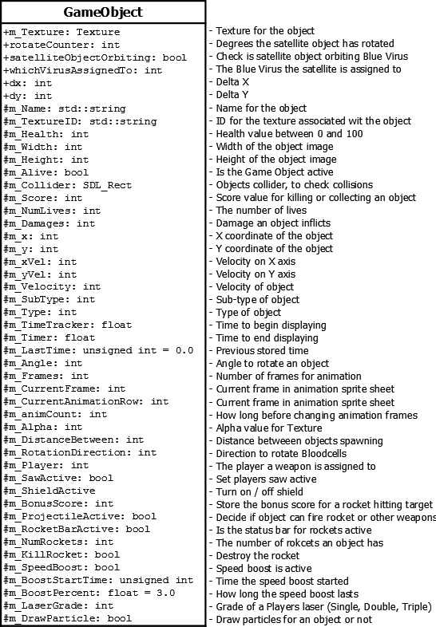

Figure Game Object Class Part 1

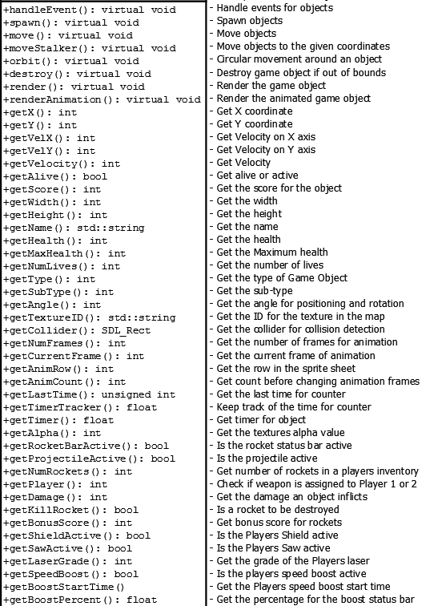

Figure Game Object Class Part 2

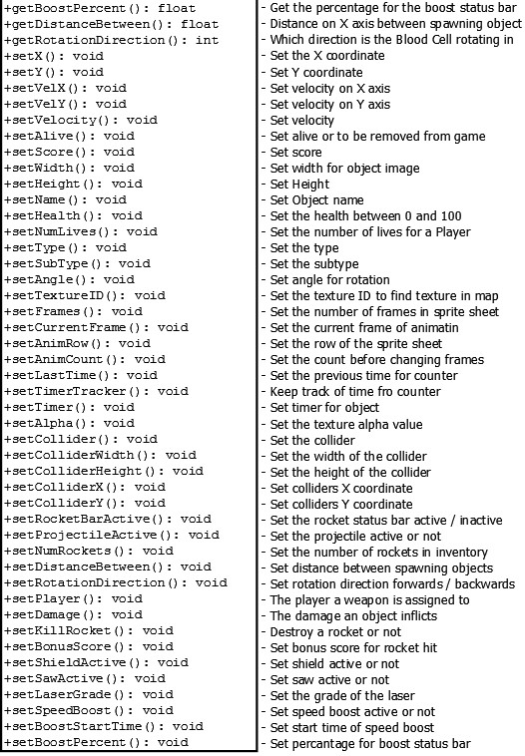

Figure Game Object Class Part 3

**Functions**

GameObject has functions to handle events such as controller input for player ship and rockets, spawning, movement, including stalker movement to move to or after objects and orbiting movement for Blue Virus projectiles. It has several render functions as the game wasn’t fully converted to an ID based texture loading system. It also handles animation rendering. There are many getter and setter methods to handle the various attributes.

**Game Object Abstract (GameObjectAbstract.h)**

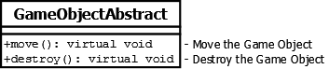

Figure Abstract Game Object class template

GameObjectAbstract (**Figure_35**) is the base class for Game Objects with pure virtual functions for move() and destroy(). Move() is used to update game objects onscreen positions, and destroy() sets the objects to be cleared from listOfGameObjects in the Game class when objects move off screen or some other external event acts on them.

**Gamepad (Gamepad.h)**

The gamepad header file has functions used to display information messages for the number of joysticks, the controller name, number of buttons, number of axes number of trackballs, number of hats for each controller (up to 2 controllers).

Some problems existed with the NVidia Shield controller registering as 2 controllers on the machine when testing, while a Logitech controller only showed up as one, this was probably down to the built-in touch pad, or extra axes. These functions helped identify differences between controllers.

**High Scores Menu (HighScores.h and HighScores.cpp)**

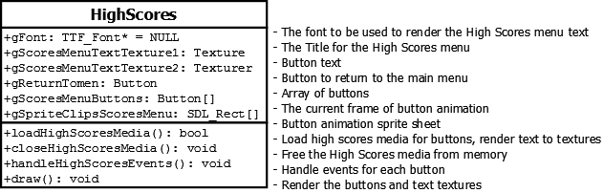

Figure High Scores class

This class (**Figure_36**) contains functions for reading the data in the highscore.txt file and rendering this data back to the high score table. The Enter Name state was to be used to enter the players name to be saved in the external high scores text file along with the players score, if the score was one of the top ten scores.

**Heads Up Display (HUD.h and HUD.cpp)**

The HUD class (**Figure_37**) contains all the information relevant to the player dashboard, including lives, scores, and weapon indicators for each player. Weapon indicators include, current laser grade, number of rockets, and an indicator for when the player speed boost is active, displaying a status bar for when the boost timer runs out. The game map is also displayed here in mini form, which can be resized by pressing a button on the keyboard or gamepad. There is also an animated game creator text on the bottom of the display (**Figure_37**).



Figure Heads Up Display screenshot

**Functions**

In the load function viewport SDL_Rect objects are initialised, allowing animations such as scrolling within the bounds of the rectangles. Several textures are needed to render the text for the display, with the static text set only once here, something we learned to do the hard way. Images are also loaded here.

The resetHUD() function resets the game map to the mini version along with its alpha value. The scrolling counter for the indicator icons is also reset to allow the icons to be scrolled again when a level or the game resets.

The render() function only renders one players side of the HUD if it’s a one player game, and performs checks for this. Viewports are used for the icon scrolling, a check is performed for the number of lives to display, and the various indicators are rendered. The values of the indicators are passed to the HUD with getPlayerInfo().

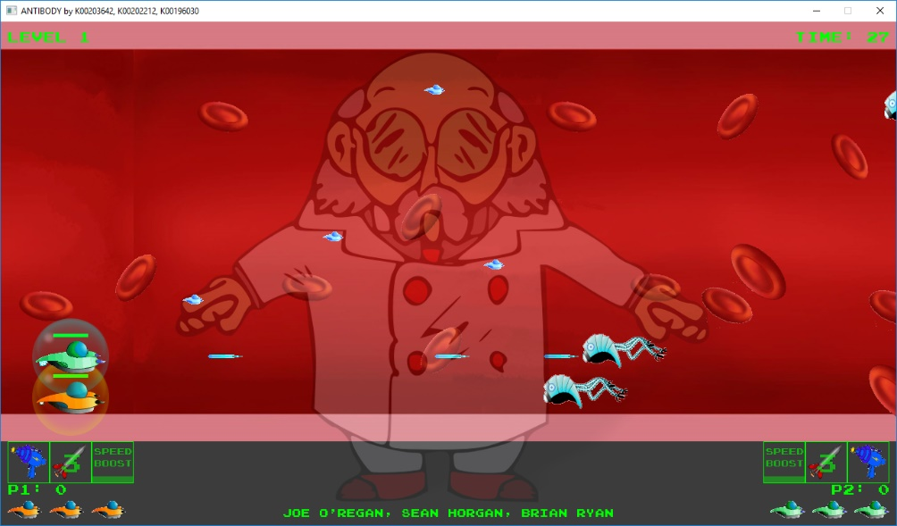

Figure Professor Map, with positions indicated by blue ships

The map positions (**Figure_38**) were to be handled with shipPositionOnMap(), it currently only shows the start and end points of the players journey through the Professors body, but passing the ships coordinates to the function would have allowed tracking of the Players ships along the path.

With the massive memory leak we experienced rendering text every frame, checks were applied to displayLevelNum(), playerScore(), and rocketIndicator() to only render text if the value changed by checking against the previously stored value.

The percentageNinjaStarKills() and playserScoresCounter() functions were to be used as part of an achievement system based on kill rates and percentage of enemies killed to enemies spawned etc. They were abandoned after the memory leak and there was no time to implement them once the leak was fixed.

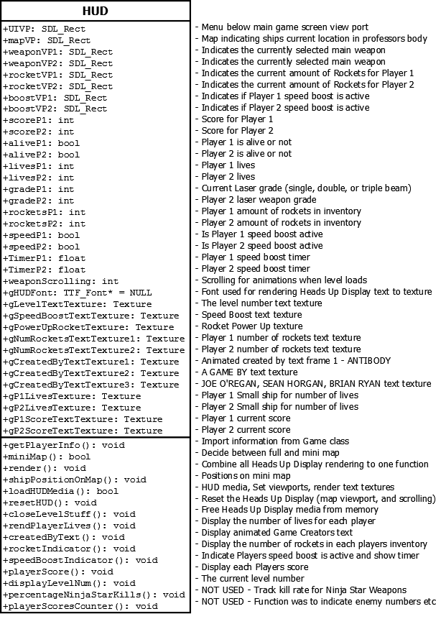

Figure Heads Up Display class

**Level (Level.h and Level.cpp)**

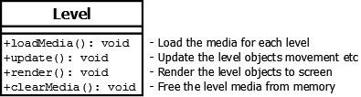

Figure Level class

The Level class (**Figure_40**) was to be used to separate the functionality for levels from the main Game class. Implementing this at an earlier stage of the game, would have made the code a lot less cluttered, and helped with implementing a more complicated game state machine.

**Main (Main.cpp)**

This is the main entry point for the game. It contains the seed for the random number, and calls the games update function. The game loops in the Game update() function when previous games we created looped in main.

**Main Menu (Menu.h and Menu.cpp)**

The Main Menu class (**Figure_42**) handles the objects for the game menu. The separate button class handles the transitions from main menu to game, and other menus. A random background colour is selected when entering the Main Menu (**Figure_41**).

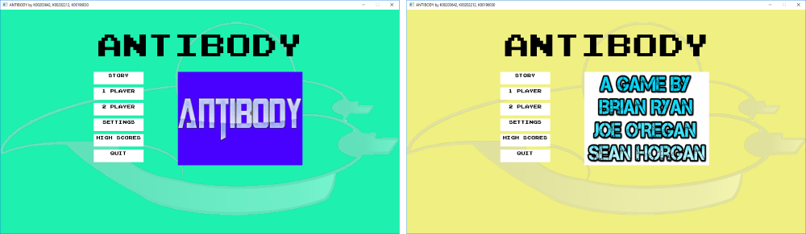

Figure Main Menu with random background colours and title / credits animation

**Functions**

As with the rest of the states in the game, functions are included for loading the media, closing the media, and rendering. There is an event handling function in the menus for handling button events. The pause menu is rendered using a function, a separate state class may have been a better option. The other menus such as Settings and High Scores are implemented in the same way in their own classes.

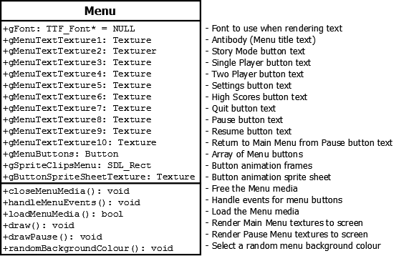

Figure Main Menu class

**Particles (Particle.h and Particle.cpp)**

The Particle class (**Figure_43**) handles the functionality for displaying the engine particles for the player’s ships. A random number of particles are drawn to the screen each frame. A random number pool is used to create the effect of the particles for both player and rockets (**Figure_44**)

**Functions**

Functions to render, check if the particle is dead, and initialise the particles are used, along with separate functions for initialising rocket and play ship particles.

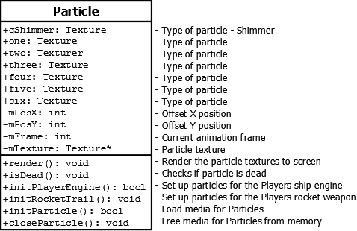

Figure Particle class

The particle system proved tricky to set up in GameObject to apply it to the rocket objects after first being set up to work with just the Player class. A lot of time was wasted moving and testing, and going back forth to the tutorials, but it worked in the end and added a cool effect for the player engine and the rocket emission.

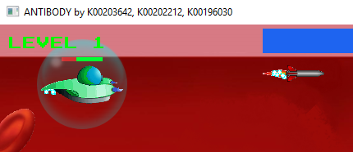

Figure Random particles are generated to represent the emissions from the Player ships and Rockets

**Player (Player.h and Player.cpp)**

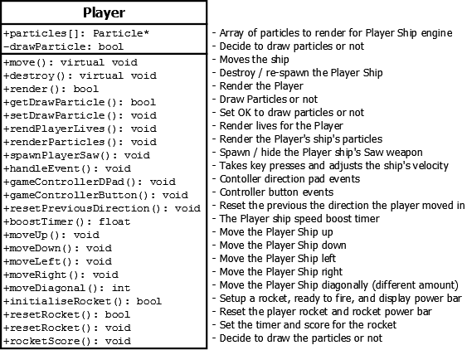

Figure Player class

The Player class (**Figure_45**) handles all the Player ships functionality, including movement, rendering the player ship, and the player lives, player input from keyboard and gamepad, rendering particles for the ship engine, and handling the player’s weapons. The Player weapons include Laser, Ninja Star, Saw, and Rocket.

Along with the coordinate, dimension, velocity and collider attributes common to most of the game objects, Player has attributes for setting the shield and saw active, drawing particles, setting a rocket active and the timer for the rocket bar, and the weapons grade of the laser. The constructor takes a sub-type to handle different Players, as Player 1 and 2 are effectively two different types of Player.

**Functions**

The render function renders the particles for the Players ship. The texture for the ship itself is rendered in the game function as there wasn’t time to test and move the flashing textures over the map and ID system of handling textures. There is a rendPlayerLives() function to display the number of lives for the Player on screen.

A function spawn the Saw object for the player, instead of showing and hiding the saw, the saw is spawned when needed and killed when not needed and removed from the game object list.

The handleEvent() function takes input from the keyboard and game controller and performs the relevant actions for the Player Ship. Moving the player per the button pressed and the velocity set. Spawning and firing weapons for each player. When a button is pressed, the action is reset when the button is released. For movement, velocity is applied in one direction when pressed and the opposite direction to counter this action when released.

For rockets when the button is pressed the power bar is shown, allowing power to build up, and then fired when the button is released, killing the status bar and showing the rocket texture.

The game controller movement stores the previous direction to reset it when the movement changes direction. Handling the controller buttons is a lot easier, as there was issues with controllers showing as more than one controller, 2 player controllers was forgotten about, it was working in previous iterations of the game, but only when the controllers were plugged in to the computer in a certain order, or with certain types of controller.

There were several weapons functions required, initialising rockets with the power bar showing before firing was a bit different to other weapons which fired on the button down and not the button up event. Another function was required to reset the rocket, and also to set a bonus score for holding the button down longer for the power bar.

The speed boost was very tricky to implement, adding to the velocity caused issues with resetting with the player ship taking off on it’s own and sticking to the boundaries. A lot of checks and velocity resetting had to be applied inside the move functions. Setting up the speed boost timer status bar function was straight forward compared to this.

The move() function moves the player around the screen and keeps the Ship within the boundaries of the game screen. Separate direction functions are used with a diagonal movement function allowing a smaller move diagonally to appear more realistic. Checks have to be performed for the change in velocity caused by the speed boost, and also boundary checks, to stop the player moving off screen.

**Power Ups (PowerUp.h)**

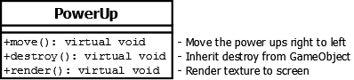

Figure Power Up class

Power Up class (**Figure_46**) handles power ups the players can collect in the game for health, laser weapon, increasing the number of rockets in their inventory, time checkpoint power ups to add time to the clock, and increasing number of lives (**Figure_47**).

The constructor creates a power up based on the subtype passed from the spawnPowerUp in the Game class, the spawn function assigns a random speed and position for the Power Up to spawn. Other functionality has already been documented.



Figure Power Ups for checkpoint, health, laser, new life, and rockets

**Random Message Generator (randomMessageGenerator.h)**

The random message generator functions are used to generate random text in the game from lists of messages for certain situations. It generates messages for a new level, blockages, a boss spawning, or the player spawning using the Game class infoMesage() function.

**Score Value Text (ScoreValueText.h and ScoreValueText.cpp)**

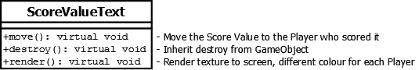

Figure Score Value Text class

The ScoreValueText class (**Figure_48**) generates the scores that appear when an enemy is shot. Scores generated by the player for killing enemy objects are displayed on screen and move towards the player using a different colour to indicate which player will receive the points. The alpha value is also lowered to make the scores less distracting on screen.

This took a lot of work and testing, with issues arising initially where only one score texture was being used, so the same score was generated for all score objects. Every time a new enemy was killed, the score changed to that value for all textures. This was solved by creating a scoreValueText class where each score now had its own texture.

**Scrolling Background (ScrollingBackground.h)**

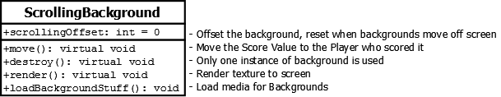

Figure Scrolling Background class

The Scrolling Background class (**Figure_49**) renders and scrolls the background images. The background is treated the same as other game objects, and can be moved and rendered with the rest of the game objects on the object list. This class was implemented after Games Fleadh and was meant to be applied to other objects such as the player map, game timer etc.

The background image (**Figure_50**) is rendered two at a time, as one image moves off screen another image moves in behind it, when the first image is completely off screen it is repositioned or requeued to be rendered after the second image, continuously looping.

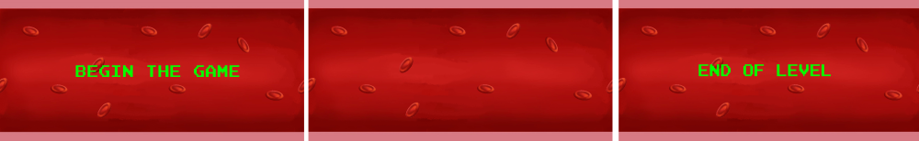

Figure Background Images

**Settings Menu (SettingsMenu.h and Settings.cpp)**

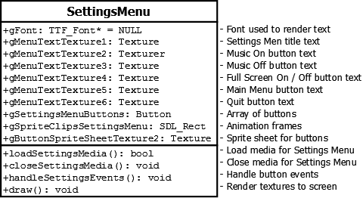

Figure Settings Menu class

The Settings Menu class (**Figure_51_&_52**) displays a list of buttons for handling game settings. Buttons are used to select options such as turn on /off music, Full Screen / Windowed. This function handles the objects for the settings menu. The separate button class handles the transitions. It is implemented similar to the other menus.

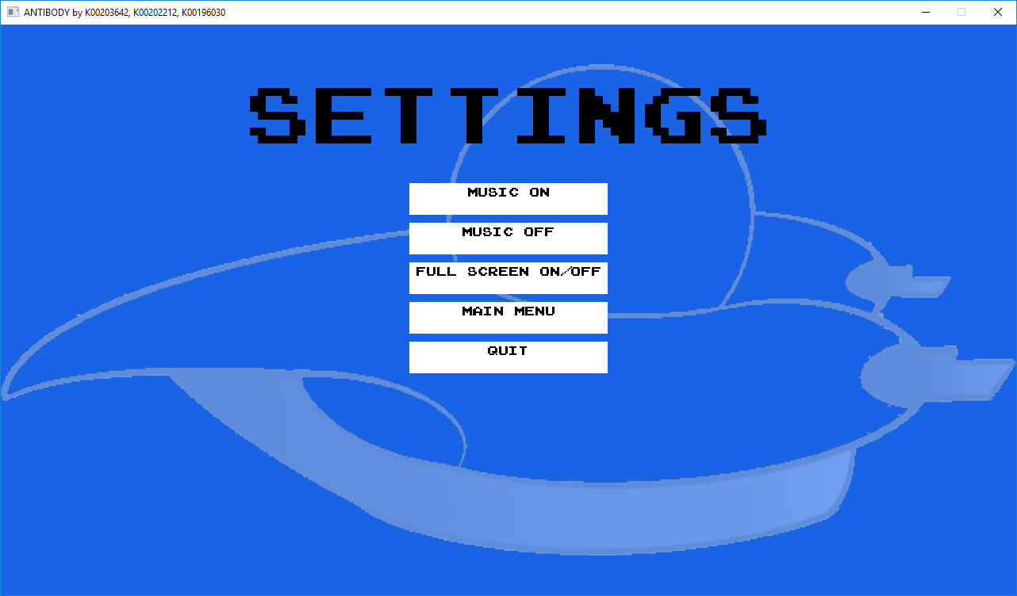

Figure Settings Menu screen shot

**Splash Screen (SplashScreen.h and SplashScreen.cpp)**

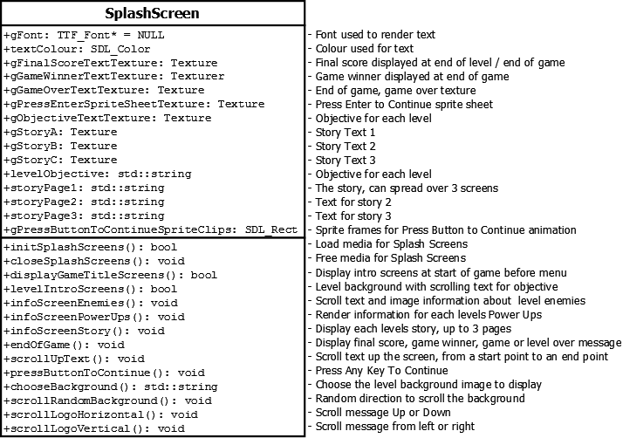

Figure Splash Screen class

Splash Screen class (**Figure_53**) handles intro screens, information screens and their random movement. Game intro screens and information screens at start of game are created in this class, and transition screens between level with scores and level objectives. Entering story mode from the menu, should generate a different set of screen loading transitions every time.

**Functions**

It contains the function that displays the final score and game winner at end of game. Backgrounds have random scrolling, up / down / left / right to give a transition affect between title, logo, and information screens.

**Status Bar (StatusBar.h and StatusBar.cpp)**

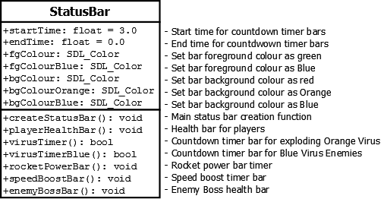

Figure Status Bar class

StatusBar class (**Figure_54**) handles status bars such as health bars, power bars for rockets, and speed boosts. Also, has a countdown virus for when the Orange virus explodes, and the Blue Virus fires and spawns a new satellite object.

We weren’t initially sure how to implement this, but following an online search we found code that used foreground and background rectangles, and rendered the foreground as a percentage. We were able to combine the separate functions into one function for handling status bar rendering orientations for vertical and horizontal, and also shrinking from the left or the right. The createStatusBar function is then

**Texture (Texture.h and Texture.cpp)**

The Texture class (**Figure_55**) manages all texture functionality for the game. Loading textures from image files, storing them to a map for indexing, and then rendering to screen. A previous constructor version took an integer parameter to rotate the textures, this was moved to GameObject. The alpha value wasn’t fully moved.

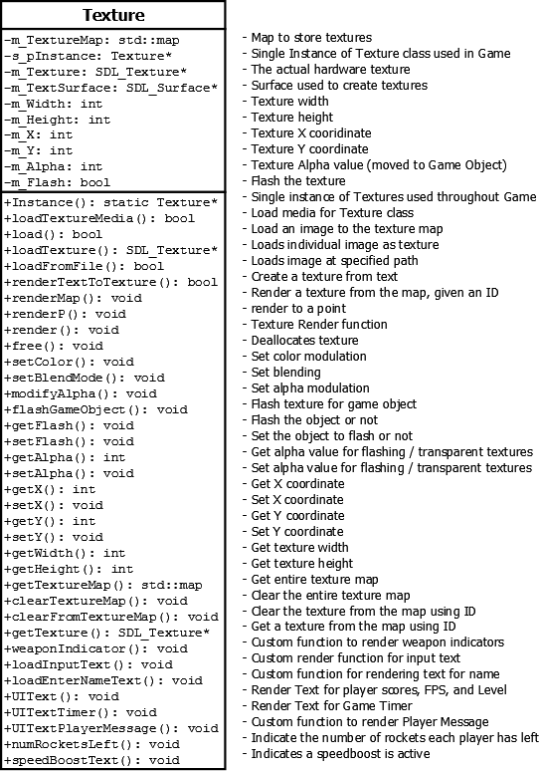

Figure Texture class

**Functions**

There are functions for two types of handling textures, individual textures, and textures stored in the map, and accessed by an ID. Textures are loaded using a path to the file initially as a surface, and converting to a texture which are more optimised.

Different render and draw functions have different techniques for rendering, using source and destination rectangles, and render quads to set their coordinate and dimension attributes. Different functions are required for static and animated images for clarity more than functionality. SDL_Points are used to find the centre of rotating objects.

There are functions to render textures from text that should have been combined to a single function, but in different versions of the game functionality was lost during roll backs. There are many custom functions to identify which text is being rendered or where such as speedBoostText(), numRocketsLeft() and UIText().

The flashGameobject() and modifyAlpha() functions handle the alpha value of objects, to make them transparent or flash, such as the game timer, and Player Ship after spawning or collisions.

A string array is used to store the path, ID, and description for error messages for each texture in the map. The loadTextureMedia() function can then load the texture and assign its ID using a simple for loop, that also identifies any texture that fails to load with the description.

**Weapon (Weapon.h)**

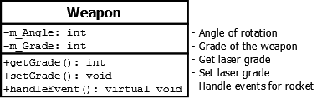

Figure Abstract Weapon class

Weapon (**Figure_56**) is the base class for all the weapons in the game. It inherits from Game Object class (**Figure_57**). It also handles events for rocket movement from keyboard and gamepad, which can be inherited by any future weapons that are created.

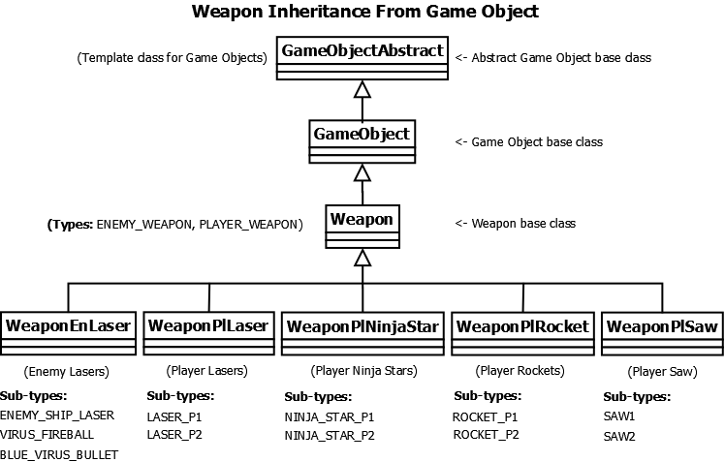

Figure Weapons inherit from Weapon base class, which inherits from Game Object

**Enemy Laser Weapon (WeaponEnLaser.h)**

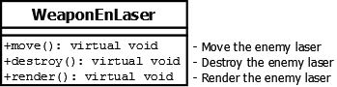

Figure Enemy Laser Weapon class

WeaponEnLaser class (**Figure_58**) handles enemy weapon objects, first starting with Enemy Ship lasers, then adding Orange Virus projectiles, and then adding the satellite projectile for the Blue Virus. The functionality is the same as previous classes.

**Player Laser Weapon (WeaponPlLaser.h)**

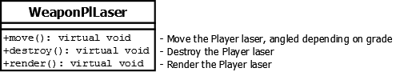

Figure Player Laser Weapon class

WeaponPlLaser class (**Figure_59**) contains the functions for spawning, rendering, and moving player laser objects. The player has two grades of laser, a single beam laser, and upon collecting a laser power up, a three-beam laser. The three beam laser fires 3 laser beams at a time, at 3 different angles. The player can fire an unlimited amount of laser beams.

**Functions:**

The move() function differs in that it has to handle movement for double and triple laser beams by setting the Y coordinate as it updates.

**Player Ninja Star Weapon (WeaponPlNinjaStar.h)**

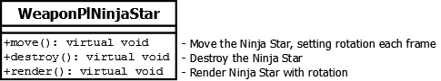

Figure Player Ninja Star Weapon class

WeaponPlNinjaStar class (**Figure_60**) handles Ninja stars which are rotating objects. They have a slower speed than Lasers, but a higher points value. Like lasers the player automatically has unlimited ninja stars. Ninja stars can be used to cut Enemy Virus in two. Each player has a different colour ninja star, and sound effect. Functionality is similar to other rotating objects.

**Player Rocket Weapon (WeaponPlRocket.h and WeaponPlRocket.cpp)**

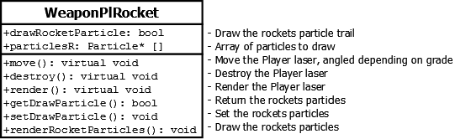

Figure Player Rocket Weapon class

WeaponPlRocket class (**Figure_61**) handles the Player rocket weapons. Players start with a limited number of rockets; this can be increased by collecting rocket power ups that appear on screen. Only one rocket can be fired at a time.

Rockets can be controlled by the player to guide towards the target. A timer appears on screen when the rocket button is held to build up power. This increases the score value on impact with enemy objects and if the player doesn't let go of the button before the timer runs out the rocket will explode

Players can collect rocket power ups to increase the number of rockets in their inventory and the current number of rockets for each player is indicated in the heads-up display. The rocket class handles particles like the player ship.

**Player Saw Weapon (WeaponPlSaw.h)**

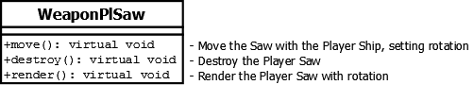

Figure Player Saw Weapon class

WeaponPlSaw class (**Figure_62**) handles the Saw weapon. The players saw weapon can be used to cut Enemy Virus enemies in half. The smaller virus objects are then more manageable for White Blood Cells to destroy. Saws are close range weapons, the player cannot be damaged while using the saw, as other objects are deflected with it. It is limited to close range which makes it less useful than Ninja Stars for destroying Orange Virus enemies, that explode on impact.

The players shield bubble disappears when the Saw is active and reappears when it is deactivated, this eliminated the need for a shield class to be implemented during testing, but would have been a better alternative for the finished game.

# Example of use

We implemented a game where the player races against time to complete the objectives, gather Power Ups, reach Checkpoints, kill or avoid Enemies, including the Enemy Boss (**Figure_63**). There is also a 2-player version enabling player to combine forces or compete against each other. The player can control a ship with either the keyboard or gamepad (**Figure_64**), and the player can also interact with a menu system to select game states, game features, and alter settings (**Figure_65**).

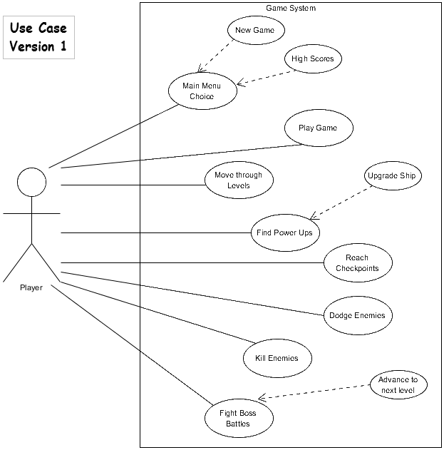

Figure Use Case Diagram

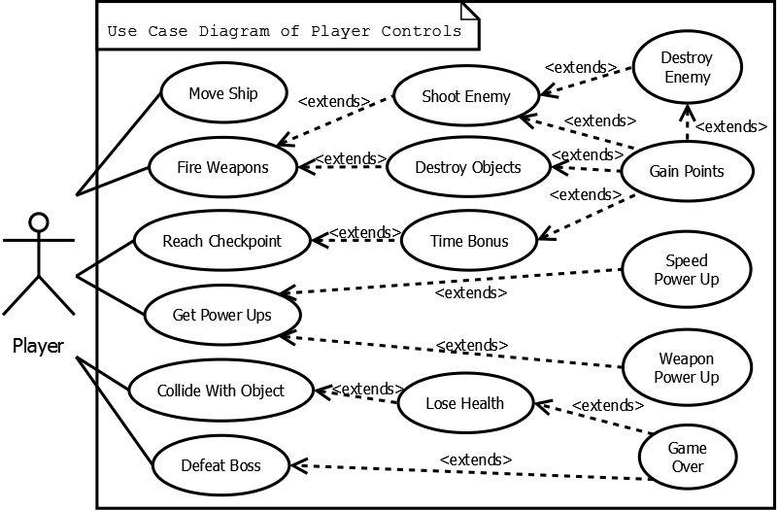

Figure Player Controls Use Case

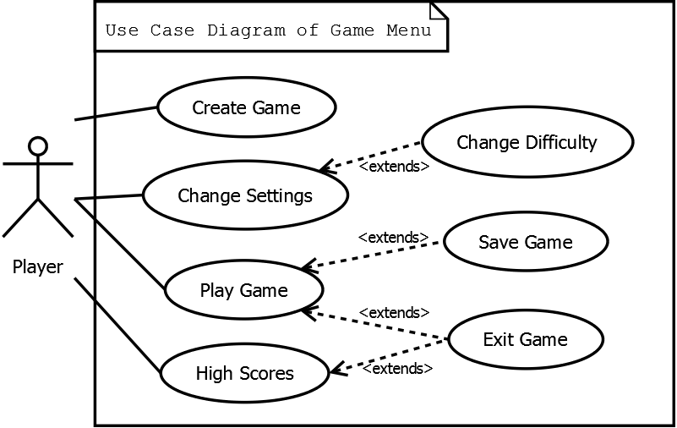

Figure Player and Menu Interaction Use Case

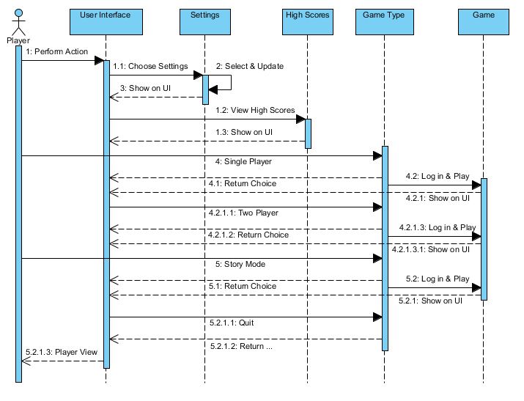

Figure 66 Main Menu Sequence Diagram

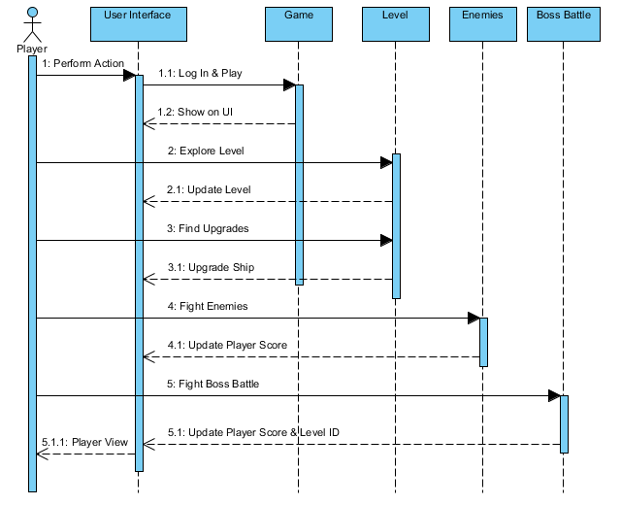

Figure 67 Game Play Sequence Diagram

# Testing & Implementation

Some of the features needed more testing than others. Any feature that proved to be too difficult to manage was separated from the main project and tested on its own. Using the bare code needed to test the feature. This was useful when testing features such as particles, movement, and collision checking early in the project.

At the start, we were slowed down by not all having the same setup on our machines, so unifying the setup across our systems so we were all using the same paths to Library and Include folder made it easy to compress whole projects, drop them on our shared drive space, and instantly download and run the project on the other side, improving productivity.

**Orange Virus**

The exploding Orange Virus projectile spawning and timer handling was included in the Game render function. A test to include it in the Enemy Virus move() and render() functions did not go to well, so it was left where it was. When calling the spawnEnemyLaser() function from here, it spawned more objects than it should have causing problems (**Figure_68**).

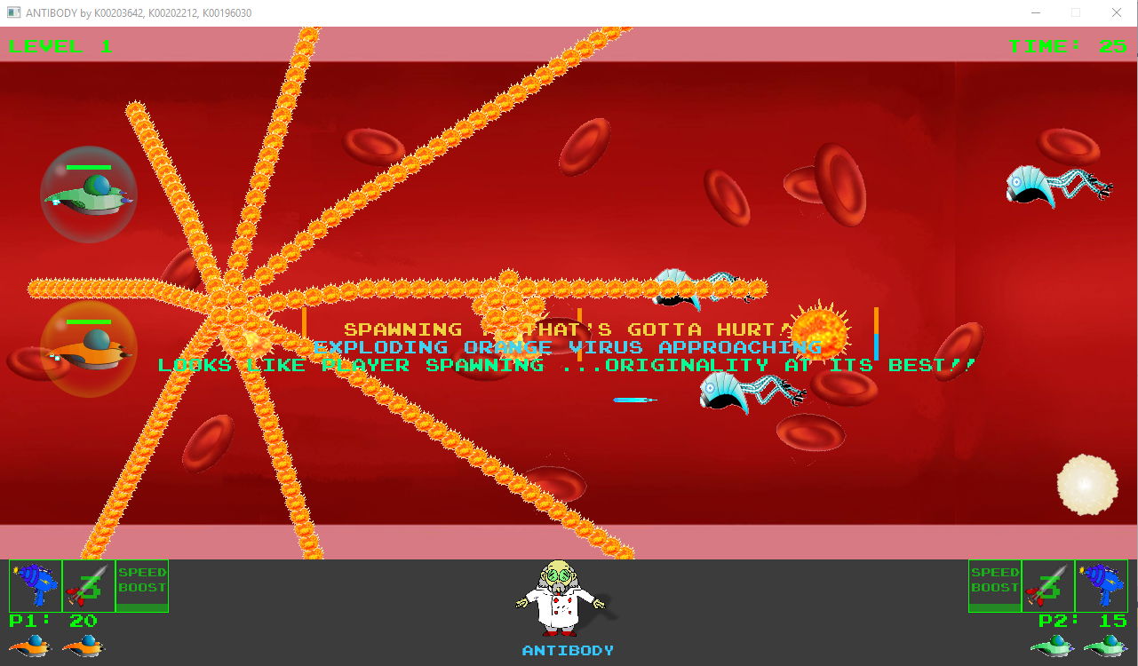

Figure 68 Moving the Orange Virus projectile spawning did not go well

**Rendering Text**

Rendering text in the game caused a massive memory leak of up to 40 Mb a second. At first, we thought this was down to changing from lists for each object to one Game Object list. Further testing showed it was the rendering of text each frame, even when the value of the text remained the same.

Moving some of the rendering to the init() function made and immediate difference. Adding checks to the rest of the rendering to only update when the text changed helped solve the rest of the leaks. The main culprit was the Heads-Up Display. **Figure 69** shows how each piece of text was tested one by one, to see how much memory if any it was leaking. It turned out they were all rendering each frame except for the information messages.

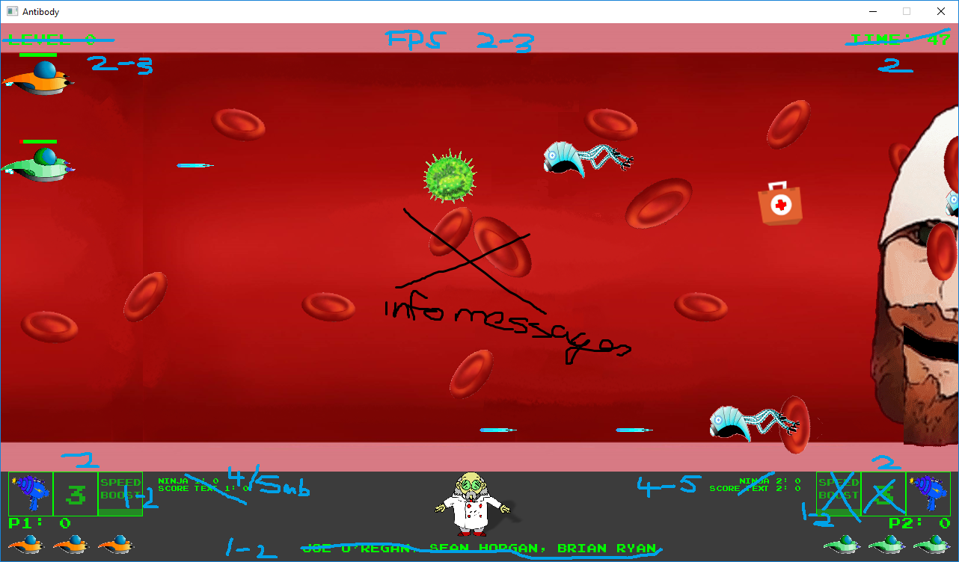

Figure 69 Tracking down the memory leak

**Blue Virus Projectile Spawning**

Initially the Blue Virus was supposed to die when the timer ran out like the Exploding Orange Virus. After a lot of testing, it turned out to be easier to have it reload, have the new projectile orbit until the timer ran out and fire again (**Figure_70).**

What was happening was, when the Virus died, the projectile immediately attached itself to the next spawned Blue Virus as it was using a number that was resetting when the virus died and being reused by the next Virus spawned. This is a problem that could have been fixed, but it worked out OK with a new projectile spawning when the timer ran out, giving a bit of variety.

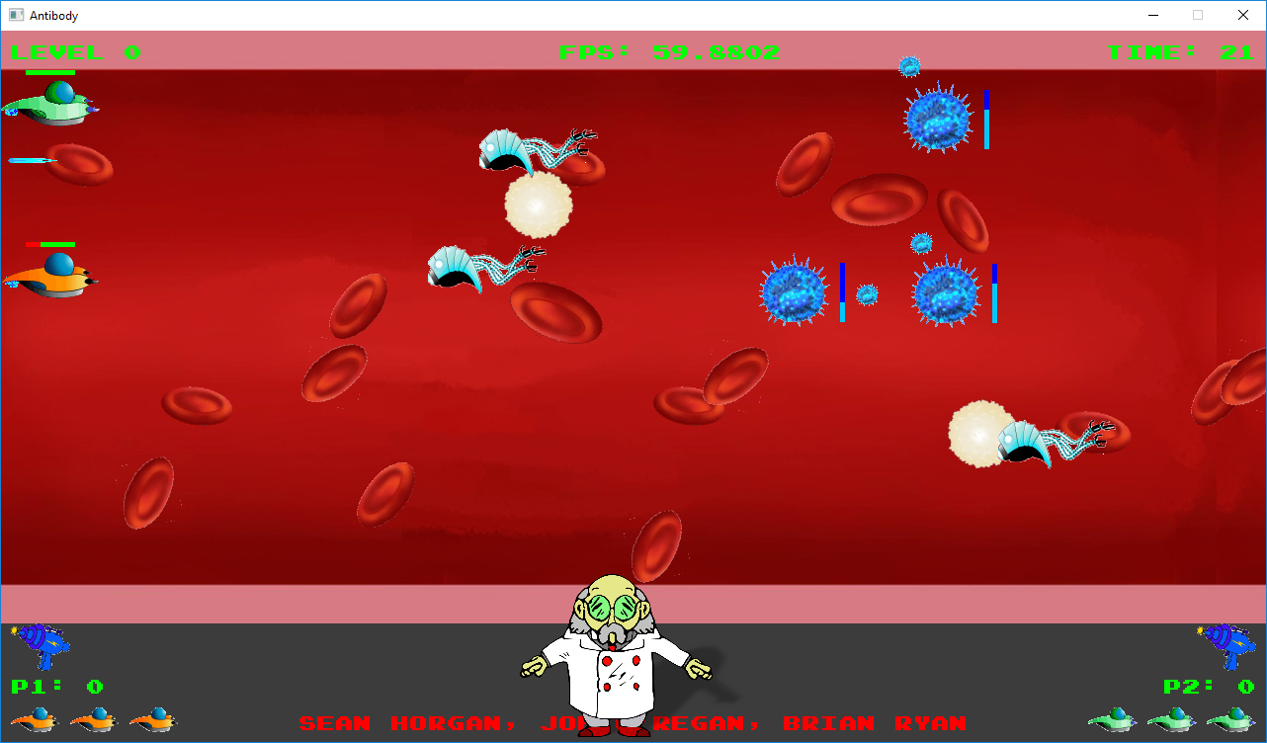

Figure 70 Testing the firing of the Blue Virus orbiting projectile

To carry out the test, all other Viruses were eliminated from the game, and an increased number of Blue Virus enemies were spawned, so their behaviour could be observed. Having the number of orbiting projectiles increase each time it fired would have been a cool feature, but with time restrictions we were unable to work this out.

**Collision Detection**

Every time a new object was added we needed to test it to make sure that its collider was working, and that we were getting the correct behaviour because of collisions between it and other objects. As an example, (**Figure_71**) shows how we tested the New Life Power up by rendering the collision boxes for objects. This also allowed us to adjust the size of collision boxes if it was too easy, or too hard to collide with an object.

One problem that we ran into when implementing collisions to objects was that multiple objects with bounding volume could not be stored properly in the list it was given. The list didn’t seem to like SDL_Rect objects attempting to be stored in it. An alternative approach that was taken was to try the same storage method but with a Vector instead of a list. This worked like a charm with no issues and allowed the storage and iteration of multiple game objects with SDL_Rect Bounding volumes.

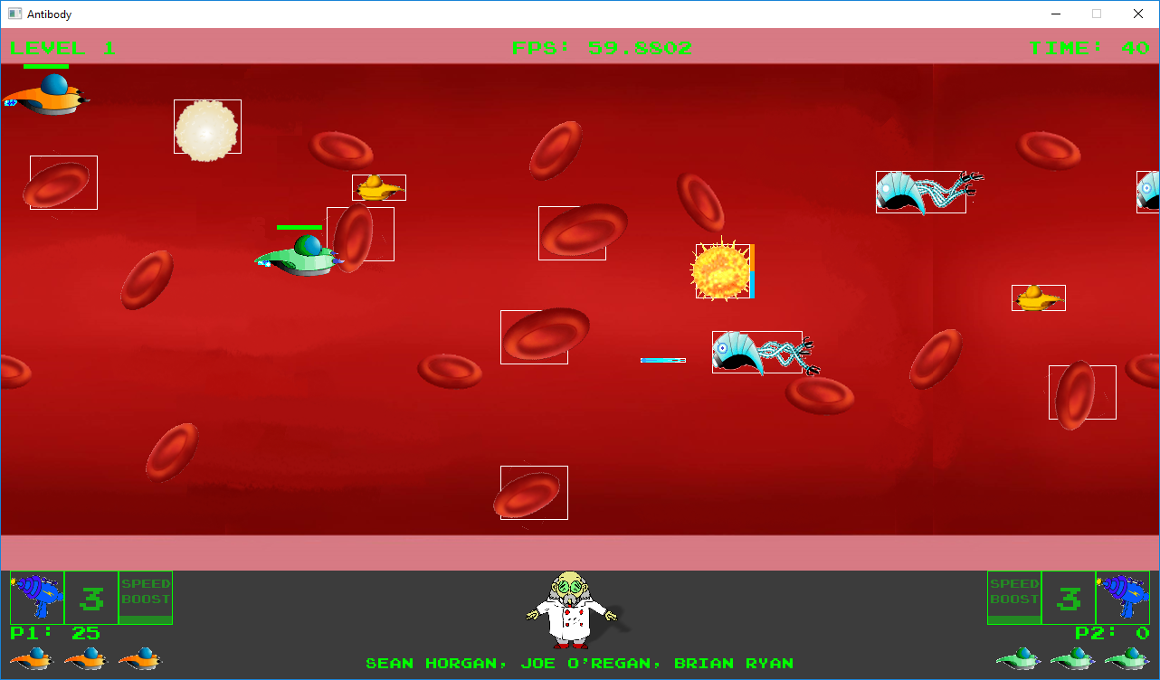

Figure 71 Testing the New Life Power Up by rendering its collider box

**Information Message Testing**

Each information message (**Figure_72**) added needed to be checked to make sure it spawned at the correct time, and disappeared after a fixed amount of time. Different colour text was used to separate Player 1 and Player 2 messages, and to highlight general game messages, but for combined messages like when the track information of a song was displayed, using the same colour for all 3 messages would have made the message clearer. We also never got around to separating the text from the main game screen to the HUD where it would have been less distracting.

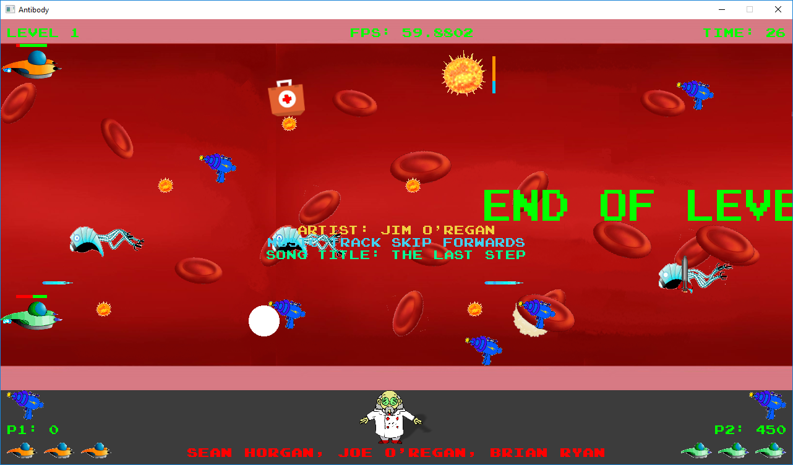

Figure 72 Testing the information messages in the game

**Object Spawning**

When we started to use random spawning for Power Ups, high volumes of objects needed to be spawned at once to make sure that all objects were being spawned, and the correct random number range was being used. **Figure_73** shows large volumes of Power Ups for Health, Laser, and Rockets begin spawned.

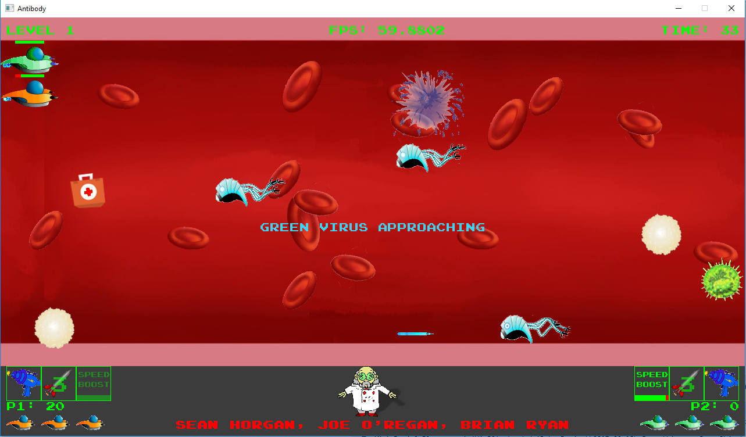

Figure 73 Testing the speed boost timer on the heads-up display

**Heads Up Display**

As a new indicator was added to the heads up display it needed to be tested. The icons scroll on to the screen at the start of each level, and images representing the current laser grade, the number of rockets in the player’s inventory are displayed. **Figure_73** shows the testing of the speed boost timer indicator.

It can also be seen from **Figure_71** that external events sometimes caused the heads up display to stop working correctly. The rocket image has disappeared from the screen here, and had to be replaced after moving its image to the texture map. What happened was the same image was being used for the power up that the player collected as the display, and only one of the uses was tested.

**Enemy Boss**

The movement for the End of Level Boss (**Figure_74**) was initially supposed to be a random amount of up and down on the same spot on the right of the screen before moving out to attack the nearest Player using the Euclidean distance from the boss to Player 1 and Player 2. During testing the movement was not reset properly, and because this looked good it was decided to keep the random up down forwards movement, and save the previously mentioned attack version for the Boss on the next level. With time restraints, this was another feature that wasn’t implemented.

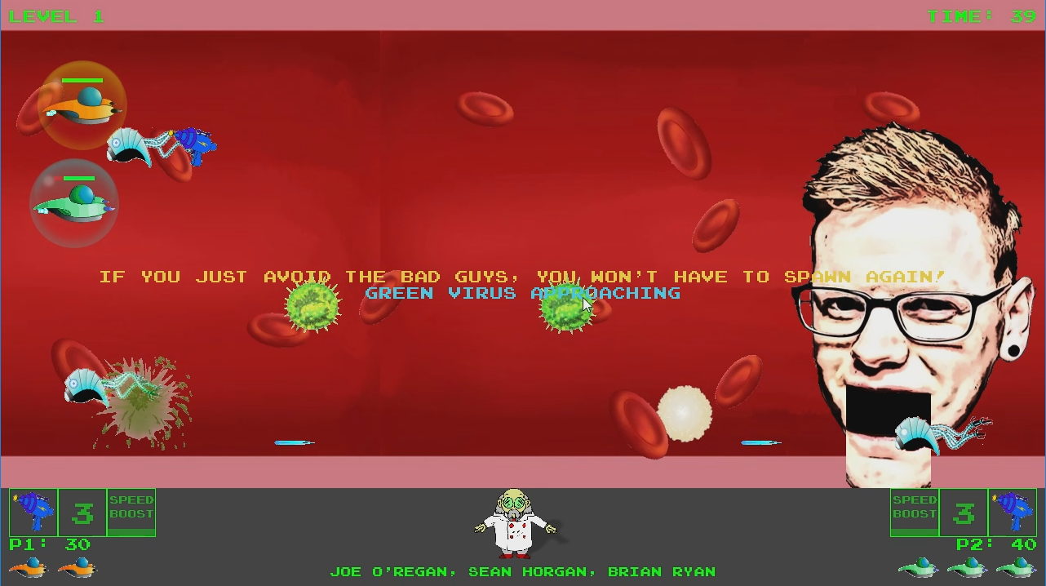

Figure 74 Testing the Enemy Boss movement

**What We Would Like to Have Implemented or Finished**

**Finite State machine**

Structuring the game with a finite state machine from the beginning would have helped with code separation, making it easier to track code. And, helping with memory management, only loading the textures required in each state.

The state machine we used was a bit too basic, and instead of first completing this and then trying to implement a finite state machine, so we had a plan b to fall back on, we ended up with a broken system spread across a few classes. The implementation would have been the same, loading the media for the state being used only when in that state, and then clearing when exiting, except when in the pause state etc.

Having classes for each state would have isolated parts of the game making it more manageable. It would have helped with memory management, and it would have helped with adding functionality such as the High Scores table, which would have required a separate state for entering names, a small state with only one use, but necessary with the overheads that entering text brings.

Being able to push and pop states, to and from a list of game states, would have helped with moving from menu state to game state, or keeping the game state in memory to be popped of the list when finished in the pause state. In the end, we settled on using the Button class to clear media for the previous state, and loading the media for the new state when moving to a new state. This was also partly managed from the Game update() function.

**Additional Classes For Objects**

Using classes for Game Objects such as the Game Timer, map, and FPS, where the classes could then be added to the list of game objects and then be updated and rendered with a simple call to these functions from a loop would have helped remove some functionality from the Game class.

After the Games Fleadh entry the scrolling background was separated to its own class so it could be used this way. Some problems were created by not testing past the first level, as the Background needed to be reset and wasn’t, so it does not appear in levels 2 and 3.

This would also have been very useful for a Level class which we attempted to create but because of the amount of code that had been let build up in the Game class over time, it became a difficulty with time constraints. This would also have been a key part of a finite state machine.

**Achievement System**

We didn’t get around to implementing an achievement system, other problems such as the memory leaks and high CPU usage problems became more important. The variables needed to count the number of objects could easily have been manipulated to create kill streak, total and percentage kills and other number based achievements to make the game more interesting for Players.

In the HUD class, work had begun on implementing an enemy kill related achievement system for Ninja Stars. After experiencing the memory leak this had to be stopped, as getting the game functional without losing weeks of work rolling back to a previous version became the priority.

**Event Handling Class**

A separate event handling class to manage events for moving objects or handling mouse interaction with menu buttons would be another feature we would like to have implemented. Implementing a system such as the observer pattern or even just to separate the event handling code, to make finding and fixing problems easier would have helped with coding the game.

**Adding Race Mode**

The split screen race mode (**Figure_75**), only needed some additional graphics to make it usable. Had a finite state machine been in place, it would be a simple case of adding it as a menu option, and it would work like how the level state would have worked.

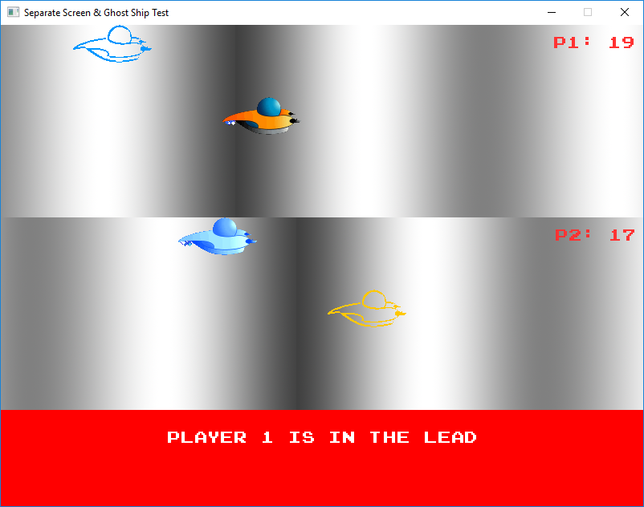

Figure 75 Race Mode with distance indicator, and ghost ships indicating the distance between players

This race mode used viewports (separate rectangles) to render the separate the player’s positions on the map to the screen. In the top right hand corner, the distance of the player is indicated, while a ghost image indicates the position of the other player relative to each player’s view.

**Map Position Tracking**

The basic map we have in the game only shows start and end points. Using the number of times the background has looped, dividing a line between start and end points, could have been implemented to show the Players position on the map. This could also be used to indicate upcoming Enemy or Power Up spawn points.

**Menu System**

The menu system wasn’t fully tested; a lot of time was wasted on it with no real end-product. Simple Changes like moving the buttons to the main menu should not have affected other menus if the menu had been implemented correctly.

**High Scores**

Sub-menus like the High Scores system were also never fully implemented, the High Scores table reads from file, but doesn’t write to it. The Enter Name state would have been used to enter the players name before beginning the level, and the score saved and displayed to the player upon completion of the game if they registered a high score.

**Further Controller Support**

We never got around to fully implementing the controller. Configuring the thumb sticks with a dead-zone were difficult concepts to program. We settled on just using the directional pad for movement. While the right thumb stick was used to control the Rocket weapons movement. Had we got the thumb stick programming figured out, this would also have been useful for a weapon targeting system, moving a pointer on screen with the right thumb stick, to set the direction to fire weapons in.

|  |  |
| --- | --- |
| **Table 4: Modifiable features in TestData.h header file** | |
| **Game Timer:** | Alter the game timer |
| **Player:** | Set the game as one or two players |
|  | Number of lives for players |
| **Background:** | Number of times the background scrolls |
|  | Background scrolling speed |
| **Levels:** | Number of levels in the game, and beginning level |
| **Messages:** | The amount of time an information message is displayed for |
|  | Turn the game and level intro screen on or off |
|  | Turn the music on or off |
| **Game Window:** | Set the game as windowed or full screen |
| **Game balancing:** | Set the number of enemies and power ups to include on screen at a given time |

# Critical analysis

**What We Achieved**

We made a significant dent in the feature list we originally drew up could add features that we hadn’t previously identified we continued to learn and realise what was possible, and what was necessary.

We got the game basics operational quickly by following tutorials and researching. Sticking to the same plot we originally conceived we tried to create our game characters while keeping them relevant to the theme of the game. We created several different Virus enemies with different movement, and projectiles.

**Graphics**

We progressed from static to animated images for game objects over time. Starting with static images allowed us to make progress on collision checking and other features, while adding the animation sprite sheets later. Loading and updating the animations is in the Game class of the final project, but we have updated it since as we can reuse the same functionality in other games.

The Texture class progressed from loading images and storing them in separate textures, to creating a map of textures, using an ID to access the stored textures. This allowed the ID for each Game Object to be stored in its class, rendered to screen with a call to its render() function, with animation frames updated in the move() function of the object.

We used 2D array of strings to hold the path, ID, and identifier for each texture. This allowed a for loop to be used to load the textures with the identifier used as part of an error message to identify an individual texture if it failed to load, using Texture::loadTextureMedia() function.

Various functions were required to manipulate and apply effects to graphics, such as rotating, and flashing. Some of the functions needed to be adapted to work with both ways of handling Textures. To flash game objects the modifyAlpha() function was adapted to take handle an individual texture and a texture in the texture map as there wasn’t enough time to move all the textures on the texture map. The alpha value for textures ended up being stored in both the Texture and GameObjects class to handle both types when it only needed to be in one.

The textures that were not added to the map were textures for animated and flashing objects. Animated textures only required the animation frames to be updated in the move() function of its class to complete the move, while the alpha value could have been updated in a similar way to allow for flashing object textures to be added. The Enemy Boss animation wasn’t moved as the spawning of lasers was dependent on the eye animation to show the laser being spawned. It is something that could be adapted but there just wasn’t time to fix all of it.

Rendering the textures should have been a simple call to each Game Objects render() function in a loop, but a lot of extra functionality ended up in the renderGamePlay function in Game. The Boss eyes lasers were triggered by the animation frame, this could have been handled when it’s move() function updated.

|  |  |
| --- | --- |
| **Table 5: Rendering Improvements** | |
| **Player** | The player flashing (altering alpha value) could have been updated in the player move function  The health bar could have been drawn from the render function |
| **Timer** | If the timer was used as a Game Object this would have allowed for the move() function to update it, and it could then be rendered to screen with its render() function. |
| **Enemy Boss** | The Boss lasers were dependent on the laser spawning animation. These could have been updated within the Boss move() function.  The health bar could also have been drawn with the render function, along with the name text for the bar. |
| **Small Virus** | The small virus animation frames could have been updated in the EnemyVirus move() function |
| **Info Message** | The information messages could have been created as objects, using the move function to update the time they appear on screen, currently handled by Game checkMessageTimes(). Then rendered to screen with their own render function. |
| **FPS** | A function for rendering could have been added to the class |
| **Rocket** | The rocket Power Bar could have been drawn by adding a render function to status bar, and adding the coordinates to the move function.  Another option would be to have an instance of StatusBar within the Rocket class, and draw it in the render function, after taking in the players coordinates and updating in the move function. |
| **Orange Virus** | The timer could have been updated in its move() function, along with the spawning of the projectiles when the timer ran out.  This was tested and did not work.  The status bar could have been drawn with the render() function. This was successfully tested and can work. |
| **Blue Virus** | Setting the timer for the blue virus status bar could have been handled in its move() function  The bar could have been drawn from its render function, or passing its coordinates to an instance of Status Bar, and adding a move() and render function to that class()  The blue virus projectile orbiting movement and firing could have been handled in the move() function. |
| **HUD** | The heads Up Display updating should have been handled in Game moveGameObjects() or update() function, not render() |
| **Game Over,**  **Menu,**  **Pause,**  **Settings etc.** | With a Game Over state, its separate rendering function could have been called, isolating it from Game (or Level) and allowing for easier memory management, only having to have the textures required in  memory for each state. This is the same for other states such as Main Menu, Pause, Settings, High Scores. Intro Screens, and Enter Name |

**Audio**

For the audio class, we used a vector array to hold the music tracks and a map to hold sound effects. Like the Texture class we initially had individual Mix_Chunk and Mix_Music objects for each effect and song. Adding the map would have allowed for an effect to be stored in the object class, but also replaced a lot of functions and variables (Figure 76, 77 & 78).

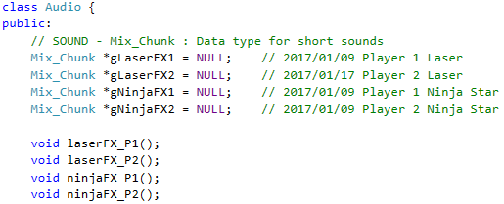

Figure 76 Initial idea required Mix_Chunks and fucntions for all effects, this was replaced with a map, and a single play function

We progressed from having custom functions for each type of sound to be played, to one single function that used the ID to load the effect, replacing several functions but remaining easily identifiable from the ID.

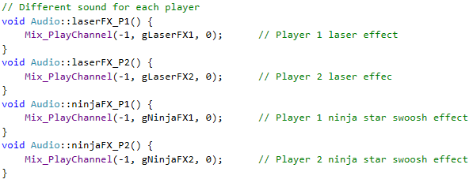

Figure 77 Initial idea involved a separate function for each effect to make it easy to identify

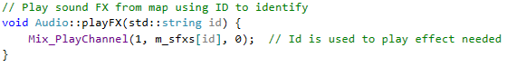

Figure 78 Final implementation: ID passed to playFX identifies the effect, replacing individual functions

# Conclusions

Overall the project went well, even though it had a lot of problems, such as memory leaks, certain features not working, high CPU usage problems brought on by objects not being deleted or high volumes of objects being created when checks weren’t applied correctly for the amounts of objects to be created, and otherer small hiccups towards the end. In the beginning unifying the setup across all machines made for quicker testing and saving a lot of time.

A lot of the issues were fixed and turned out to be very useful learning opportunities, changing our perspective on how features should be implemented and the many ways a programmer could go about doing one thing. Then trying to find out which of the many ways of implementing a feature is the most efficient and least costly on the memory turned out to be excellent experience for us all as programmers, as we may need to keep these things in mind such how secure is a function and can it be exploited or is there a less memory-intensive way of creating multiple objects when in a job environment.

**Planning**

One of the biggest constraints was time, because there are still so many features and improvements that could be added to the solution. However, a deadline is needed as it is easy to go off-track and begin working on features and improvements that are of a lesser priority to that of the core features that were initially discussed when in the design phase. With a time-constraint, it forces members to keep the bigger picture in mind and get the main features that are high up on the feature list pushed out and polished.

Our Gantt chart went out the window when we finished researching and started coding the game. As we had no experience of this level of project, it made it hard to gauge the work required to complete tasks, or what order they needed to be implemented in. Some features on the list were completed in a matter of hours, while some of the features were never fully completed even after months of work. The project has given us a better idea of how to prioritise features, and a better indication of features that we completely overlooked or were unaware of at the time such as state machines and design patterns. Now that we know what these are, we are fully aware of how important they are not just in games, but software in general. Researching is key to good planning. And sticking to a plan, and making sure everybody is on the same plan are a couple more lessons learned.

**Communication and Team Work**

Collaboration was made easy with the use of the group chat in Google Hangouts and the collaborative repositories that are Google Drive and GitHub. Instantly working on newer versions of the game was also made a lot faster with the use of a SDL2 library folder structure which was maintained across all the member’s machines. This allowed any version of the project to be downloaded, opened, and compiled in Visual Studio without any setup and tinkering with includes and lib files. This sped up progress for a while, with only having to compress the whole project folder and drop it on the google drive space to be shared, and simply downloading and uncompressing to use immediately.

Another simple technique used was starting each compressed project file with the reversed date e.g. 2017-03-08a, 2017-03-08b, so the most recent version could be immediately identified, also using descriptive titles. This was extremely useful for writing documentation as opening the code folder gave an instant overview of what order tasks were worked on, or completed.

Issues that challenged the group dynamic after a great start included not adapting our communication system as the project progressed. Not improving on our method of indicating what changes had been made or additions added to code. Our simple but straight forward commenting system of adding our name and the date anywhere a key change was made became irrelevant as the amount of code and number of classes grew. Small changes that one group member made to improve the feature they were working on had knock on effects for other group members features.

We also failed to re-prioritise features and work as the project evolved only sitting down to agree on new feature lists a few times, when weekly revisions should have been a key part of our project agenda. Time limits should also have been put in place on features, as many features such as the state machine, menu system, and high scores table should have been reassigned or dropped. The main problem here was after putting in a lot of work it’s very hard to give up on something that you think you have solved, but is just not fitting in to the project.

**Testing**

We initially had been testing features as separate units, such as the particle system, but we started to think this was wasting a lot of time, when the amount of time that was lost trying to make changes to an entire project turned out to be far greater. Any time a roll back occurred weeks of work could be lost.

As an example of this, while finalising our entry for Games Fleadh the memory leak issue arising from text being rendered to textures each frame instead of only when it was needed, was solved by setting a flag to let the computer know it’s done, and don’t do it again until the text needs to be updated. As we were continuing to work around it, we only realised the week of Games Fleadh that the last stable version before the memory leak kicked in was 3 weeks previously. This build of the game happened to be immediately prior to moving from multiple vector and linked list for each object type, or related object type, to one Game Object list. After testing and a lot of searching through the code it was then we realised it was the text rendering that was causing the issue. This led to more time being lost both in rolling back to the previous version, and rolling forward to the fixed code as we felt we couldn’t afford to lose time by waiting for the problem to be identified. If we had been testing the individual features thoroughly as we had at the beginning of the project this may have been avoided.

We left a lot of aspects of the game untried, unfinished, untested and unremembered. A lot of problems were brought about by laziness. Adding in code, compiling the code, being happy that the code didn’t crash, and not bothering to check the outcome. Also, not bothering to compile for hours after making a whole range of changes was in the top ten of “Dumb things not to do when working on a project that is already not very stable”. Forgetting to comment and document even small changes lead to a lot of issues, also, “Let’s just put this code here for now” moments, such as putting movement code in the rendering function and forgetting all about it. Documenting, testing, and clearly marking changes that have been made, especially on deadline days, are some key lessons learned for all of us.

The project was a massive learning opportunity, showing us a lot of way’s we could have done things better or alternative approaches to implementing features which could have saved time and reduced code. One of the biggest lessons learned from this project in terms of programming a game is the use of a state machine from the beginning.

Prior to second semester of third-year we had no knowledge of the finite state machine or other game patterns. The game was initially written with a class-heavy, object oriented approach which consisted many object and classes, a main game loop, calling functions from the game class and hard-coded levels. The finite state machine would have taken a bit more time to implement in the beginning compared to the hard-coded approach, however in the long run it would have allowed for significantly easier and time-efficient implementations of states such a menu state, settings state and pause state.

Coupling the state machine with a data-driven development approach using Tiled and XML files for levels, collision layers and sprite spawns, this would have allowed for faster implementations of various in-game levels. Applying changes and updates to such levels would have a been lot faster and would not require the code to be recompiled as all the objects and changes are stored in data. The introduction of a level class would provide a simple template for reading in and parsing Tiled XML files for the levels.

The introduction of game patterns would also have made development simpler and faster, while providing us with more features to implement that might have seemed more difficult to implement using the hard-coded, class heavy approach. For example, the introduction of the Observer Design Pattern would have allowed for simple observation of certain events that happen within game such as a player dying ten times or completing a level without killing a single enemy and then that pattern could trigger an achievement system to unlock an achievement for the player. The Observer Pattern would eliminate the need to clutter our physics/collision code with achievement code. This would keep code neat, concise and only contain code relating to that department such as physics, audio, textures, etc.

# Bibliography

Dawson, 2010. Beginning C++ Through Game Programming, 3rd Edition. 3 Edition. Course Technology PTR.

Shaun Mitchell, 2013. SDL Game Development. Edition. Packt Publishing.

Game Programming Patterns. 2017. Game Programming Patterns. Robert Nystrom. [ONLINE] Available at: http://gameprogrammingpatterns.com/. [Accessed 27 March 2017].

Lazy Foo' Productions - Beginning Game Programming v2.0. 2017. Lazy Foo' Productions - Beginning Game Programming v2.0. [ONLINE] Available at: http://lazyfoo.net/tutorials/SDL/index.php. [Accessed 26 January 2017].

# Will Usher. 2017. TwinklebearDev SDL 2.0 Tutorial Index. [ONLINE] Available at: http://www.willusher.io/pages/sdl2/. [Accessed 29 March 2017].

# References

*All referenced material should be listed here. Use the Harvard referencing scheme (see* [*http://mislibsrv.lit.ie/screens/writeitright.pdf*](http://mislibsrv.lit.ie/screens/writeitright.pdf) *). There are also some useful Harvard reference generators available online. You are encouraged to use illustrations where appropriate in your report but it is important that all such elements are clearly labelled and referenced in the text.*

***Game Art (Explosion.png):***

*OpenGameArt.org. 2017. OpenGameArt.org. [ONLINE] Available at: http://opengameart.org/. [Accessed 27 March 2017].*

***Blood Explosion Animations:***

*Vicente Molina. 2017. Vicente Molina. [ONLINE] Available at: https://vicentemolina.neocities.org/animation/animation.html. [Accessed 19 February 2017].*

***Laser Power Up Image:***

*Free vector graphic: Laser Gun, Laser, Alien Gun - Free Image on Pixabay - 155598. 2017. [ONLINE] Available at: https://pixabay.com/en/laser-gun-laser-alien-gun-155598/. [Accessed 27 March 2017].*

***Cartoonised Boss Image:***

*Cartoonize.net. 2017. Convert to Cartoon - Convert photo to Cartoon - Cartoonize Yourself. [ONLINE] Available at: http://www.cartoonize.net/. [Accessed 02 March 2017].*

***Text Generator:***

*Logo and Graphics Generator - Cool Text. 2017. Logo and Graphics Generator - Cool Text. [ONLINE] Available at: https://cooltext.com/. [Accessed 27 March 2017].*

***Status Bars:***

*SDL :: View topic - Progress Bars (Health bars, etc..). 2017. SDL :: View topic - Progress Bars (Health bars, etc..). [ONLINE] Available at: https://forums.libsdl.org/viewtopic.php?t=11040&sid=0c796abe9954dba84ee2814c32c85f5c. [Accessed 18 January 2017].*

***FPS Measurement:***

*SDL Documentation Wiki – Average Frames Per Second Measurement*

*Available at: http://sdl.beuc.net/sdl.wiki/SDL_Average_FPS_Measurement*

# Appendicies

## Joe O’Regan Reflection

**Introduction**

This report will describe my contribution to the team in technical, project management, and documentation deliverables. It will also include the work I completed, my role in the group as group chairperson, a reflection on my input to the team, and my thoughts on the group dynamic. I think Brian and Sean have given a good account of we started off our project, so I will try to focus on the group dynamic, the problems we encountered, along with my own contributions.

**My contribution to the team**

My role as Chairperson involved organising meeting times and agendas, managing conflict, and encouraging the participation of the group members. At the start this was straight forward, as the agenda planned itself, as we organised our research, game ideas, and discussed what we needed for project deliverables. In the second semester, this became difficult with time constraints, and increased work load as our project expanded. In the end issues caused by misunderstandings communicating in the group chat could have been avoided, there was still some misinterpretation of requirements face-to-face. I still managed to learn a lot about how I could have managed things a lot better, and what we initially got right before the project grew.

**Research**

My initial research over the summer focused on C++. I touched on Unity as I was impressed with Brian and Dominik’s achievements with this game engine. When we received more detailed project requirements, I started researching Cocos2d-x. It was hard to get up-to-date information due to a recent version change, and tutorials were not readily available like with SDL. I was still very enthusiastic about the opportunity to program games on mobile devices, and completed tutorials for some basic games in both Unity and Cocos2d-x.

We decided as a group to use SDL, after Brian constructed an impressive demo which we used as a prototype for our first presentation. The advantage of having all the basic features of a game in one set of tutorials (LazyFoo productions) sold both myself and Sean on the idea.

By Christmas I’d completed the full set of tutorials twice, first to see how it worked, highlighting the key points, and a second time to help come up with ideas for the game. Any time I was running out of ideas I referred to these tutorials for inspiration.

**Programming**

After semester five, I had started to fall behind as far as progress went. Brian and Sean had created a prototype and started to add features. I felt I needed to complete all the tutorials, and recreate the work they had completed, to get an understanding of what was needed. Aspects essential to our project were missing from these tutorials, such as implementing a game loop, and separating into classes, but what was available was a goldmine of knowledge.

Over the winter break, I began coding features on our list. I printed the list, matched features up to relevant tutorials, and taking Sean’s first project upload with laser spawning, I expanded on the idea, adding an enemy ship, and ninja star weapons.

Features I added, and how they were implemented, changed as the project evolved, first working from one massive update class, this had to be separated to functions, and then functions updated to work with many objects, not just one object.

Then a lot of work went into creating classes, not only as a part of good object oriented design, it became difficult to manage one massive Game class. Even with a better understanding of classes as the project progressed, there was still issues towards the end with the Scrolling Background implemented as a class, and not being reset so it disappeared in levels 2 and 3.

**Creating Features**

I implemented a lot of features in the project, and touched on every aspect of it. The only part of the project that I didn’t ‘interfere with’ was the collision work done by Sean, if it’s not broke, don’t fix it (Something I should have done more often). I separated part of the functionality to a header file, and it probably should have been implemented as a class, but we had problems with SDL_Rect not working across classes. This was more to keep the Game class manageable than anything else.

There were other ideas I reorganised, separated to classes, or expanded on that were mostly the other group members work but some of the main work I did included:

**Weapons**: Expanding on Sean’s Laser weapons, I added rotating Ninja Stars, 3-beam laser, Saw, Speed Boost, Enemy Laser, and user controlled Rocket. Different colours for identifying Player 1 and 2 weapons. A list to manage each type of weapon, eventually progressed to a list for all weapons, before eventually a list of game objects was used. Late additions I added for weapons include the shield, and double laser.

Constant adjustments had to be made to how weapons were spawned, where movement and rendering was handled, and checks so weapons didn’t interfere with each other, or destroy objects that were not to be destroyed.

**Enemies**: I added the Enemy ship moving right to left, that fires lasers, altering the colour of the Player ship, Sean expanded the idea further to a Nano-bot, which I then animated. I added a Green Virus with movement that tracks the player’s Y coordinate, an Orange Exploding Virus based on Eugene’s suggestion, with a timer status bar, that explodes sending projectiles in 8 directions, and a Blue Virus with an orbiting projectile based on a suggestion in class by Liam, the movement was altered when a 2nd player was added, to move to the nearest Player.

The Boss enemy was initially based on Daniel Gadd as a joke, and was replaced with Lorcan, as he volunteered thinking I wouldn’t bother. This enemy spawns lasers out of its eyes, after an initial spawning animation and Viruses out of its mouth when moving backwards. We had an idea for a snake type enemy I think I got inspiration from researching R-Type. An enemy that moved point to point with the body in sections. The art work wasn’t created, so the idea was never implemented.

**Game Objects**: I worked on moving functionality to game object to be inherited by other objects and to reduce repeating code. I attempted changes like a universal render function, that didn’t quite go to plan, and a separate renderAnimation() function when animation handling was separated from Game class to each objects move() and render() functions. After adding one universal Game Object list, I added type and sub-type attributes to manage objects on the list.

An abstract base class for Game Objects is something that was added later, had it been added at the beginning, it would have helped creating one list. Problems arose first creating lists of type list, and then trying to add Player objects to the list, because of attempts to access functionality not present in Game Object, and out of bounds referencing.

I added random spawning attributes for Game Objects for speed, and distance between objects. I wasn’t sure how to spawn based on time, as the timer was implemented after spawning, so distance between objects base on the X coordinate was used.

**Background**: I added to the background scrolling, adding a loop and counter, so the background stopped on an end frame, to identify the boss scene. The counter could also be used to spawn objects at certain points in the game, I applied this to spawn blockages half way through level 2, to give the player time to adjust while dealing with additional Virus types.

**Collisions**: I started researching circular collisions, but as Sean had been working on box collisions already, I decided to concentrate elsewhere. I added flashing for Player collisions, and collision checks for additional objects I created.

**State**: I added an initial game over condition for when the timer ran out, followed by game winner message based on the score. The simple state machine used an enumerated list to hold the current state, starting in the menu, and progressing to Level 1, adding states for settings, high scores, pause, story, and 1 and 2 player options. A finite state machine would have been a better option, helping with memory management, and game progression, and implementation. Issues occurred with objects not resetting when the game progressed, and objects continued to fire, and explode when game transition screens were rendering.

**Textures**: I moved functionality for textures to its own class, handling rendering for textures, text, flashing, and rotating objects. Adding the singleton pattern helped with accessing Texture functionality. The map helped reduce the number of functions, as I had started to create descriptive function names, but an ID in the function call helped identify textures using a map. I also added an array with the texture path, id, and descriptor. If the state machine had been regraded each state would have had its own list of textures. Another alternative would have been a data-driven approach, handling textures with an XML file.

**Timer**: I took over creating the timer from Brian at the start of the project, it was one of the toughest parts to implement in the beginning requiring both our inputs, and between us taking about a week to implement. I tried moving the timer to the HUD class but it failed to render correctly. Adding a timer class was one of the things we didn’t get around to.

**Audio**: The Audio handling evolved over time too, I added some downloaded Laser effects to begin with, and added the swoosh sound from a tutorial for Ninja Stars. I added an array for music, selecting a random track each time the game began. I then added skip forwards/backwards for the tracks. I also added 2 original songs I tabbed out as midi files in guitar pro, and its sound engine makes them sound realistic, and also 1 I worked on with my brother (Files and score included on DVD). I added a map for sound effects to search by ID, this replaced a bunch of custom named load functions to play sound effects with one function. I also added a singleton for access. Work on adding stereo panning was abandoned when I couldn’t get it to work.

**Text**: As part of creating the timer True Type Fonts were to be added to display the time. I had left out the initialisation code causing slow progress with this feature, after trying to help Brian. Problems with fonts not loading correctly, and our biggest problem a massive memory leak of 40Mb a second, caused by rendering text every frame, instead of when it needed to be updated, made sure text was one of the biggest headaches of the project.

**Controls**: Keyboard support was simple enough, problems arose with resetting movement between levels. It took me a while to identify the cause of a problem where the player just took off on its own at the start of a level. I solved this with a check for a button release, if a player held a button down while the level progressed the movement carried over to the next level.

It was also difficult to implement the gamepad stick control for Player, it was easy to reset movement for D-pad to solve movement issues, but factoring the kill zone for the thumb stick hurt my brain. Force feedback was also not tidied up, I set default feedback for button presses, and never tidied it up later.

**Blood Cell**: I added the forwards/backwards rotation, and up and down movement for blood cells. Large blood cells were to act as obstacles, then have a negative effect on scores, when players split them, but this wasn’t implemented. I added more advanced movement for White Blood Cells so they swooped in to tidy up Small Virus objects, helping to create a purpose for all our objects. Up until then it was glorified tumble weed, the simple movement was kept for when no Small Viruses were present.

**Player**: I added checks to the movement, enabled flashing for collisions and spawning. I was hoping one of the other guys would work on removing the repeat code, such as collision checks, for each player after I added Players to the game object list, but we were all under pressure with various features. I added functions for updating player health and scores.

**Animations**: These progressed from being handled only in Game.cpp to finally adding sprite sheets to the Texture map, and the functionality to objects move() and render() functions, adding variables to GameObject to handle frames. Changes had to be made to solve problems with all objects of the same type rendering animations on the same frame, and reducing sprite sheet code with a single common function.

**Status Bar**: I didn’t know how to go about creating the status bars, I had created them in the previous text based game but wasn’t sure how to do it for graphics. I found a tutorial online which I first adapted to a single function for horizontal and vertical bars. Then a class for rendering different orientation and start points. They were first added for Player health bar. Then custom functions were created using the earlier universal status bar function.

**Menu**: Brian had started work on menus, I helped him with the code, and added a couple of sections to the menu itself. We also re used the code I used for high scores in my CA game, when he ran into issues with reading / writing to files. This code relied on the enter name state to be operational, which was not achieved as I struggled to implement a finite state machine. I solved an issue where two game windows were being created on top of each other, by changing what the button presses in the menus did. They were calling Game update(), but I changed this to setting the state enum.

**Heads Up Display**: I added a section beneath the game screen for a player dashboard, resizing the game window. I added a mall ship to represent Player lives, then an icon to represent the current weapon, eventually changing it to represent the laser grade. A viewport was added to allow scrolling of indicators at the start of each level. Speed boost indicators, and number of rockets in inventory were then added. Along with the player scores moved from the top of the screen. An attempt to add text to represent a kill streak achievement was not finished, as the memory leak became an issue.

**Messages**: I first added game over messages, then player notifications, and further expanding to separate Player 1 and 2 messages, then adding general messages. I added random messages to be displayed for blockages, spawning, and Boss notifications.

**Scores**: Several problems arose having separate checks for each player for many functions including scores. I added scores to be displayed when enemies were killed. I then added functionality to move the scores towards the players score total in the HUD, before deciding to move them to the player’s ships. I added distinct colours for each player, then set the transparency lower as there was a lot going on in the game screen.

**Power Ups**: Sean began work on power ups for health, but I added laser, new life, and a rocket power ups. I also compiled the power ups into one class, with sub-types to distinguish between them.

**Game Window**: I adjusted the size of the game window twice as more screen space was needed. I created a split screen race mode that was not implemented in the game. I also added a setting to change between full-screen and windowed views.

**Map**: I added a viewport to the HUD for a map of the Professors body. I then added the option to resize the map by pressing ‘T'. I lowered the full screen map transparency so it could be used mid-game, and added level start and end points. We didn’t get a chance to implement the players current position on the map. I was going to use the background scroll counter to plot the position on a line.

**Explosions**: I added downloaded explosion animations for collisions. I then added further blood explosions, adding different colours to this for each Virus.

**Splash Screens**: I added the game title and credits screens first. I then added functions for adding text and scrolling the logos. After creating a separate class, I added random scrolling for backgrounds in the games information/story/objective splash screens. The press button to continue function didn’t go exactly to plan, but works OK.

**Game**: I attempted to separate a lot of the game functionality to a level class before the final code submission, but there was too much code relying on the game class singleton, and it made it difficult. It would have made things more manageable, and is something I would implement from the start on the next project. Setting the entry point helped solve problems when trying to increase the functionality associated with the singleton, with help from Liam.

**Testing**: I put a lot of work into tracking the memory leak, and High CPU Usage issues, coming up to Games Fleadh. The last stable version was 3 weeks prior to this, and I had a lot of work that would have been lost on roll back. I wasn’t happy to lose, or move all the work to a previous version.

Having tested the issue, and proving it wasn’t the addition of the GameObject list, and in fact it was the text rendering causing the issues. I had to put more effort into rectifying the problem, applying checks to each piece of text so it only rendered text to texture when updated. We should never have let so many lists build up in the game in the first place, and I wasn’t happy to revert to this method.

**Team Work**

I added a lot of features to the game, all of this was made possible by the work of Sean and Brian, whose ideas I expanded on, or adapted. for a large part of the functionality I added. I also latched on to suggestions by our lecturers, and project supervisors, trying to expand these or add an original spin on the idea. Our ability to swap features we were assigned in the original Gantt chart plan at the start helped with progress, but as the project grew, we did become more invested on the features we were working on, and it became harder to pass them on or wrap up work on the feature. Overall, I think we worked well together adapting, expanding, and completing each other’s work and ideas.

**Documentation**

For this report, I created all the class diagrams, and supplied the details of the features I worked on. For presentations, we all took turns updating slide shows, adding information, story boards, charts, and other necessary information. Some of the earlier documentation we could reference for further reports and presentations, and further expanding as we added more to the project. With reports, we took an even number of sections each to complete, then took turns reviewing and updating the documents.

**Application of team work theory**

We decided our roles in the group early, before we had learned in class what attributes would suit each position. With Brian’s organisational abilities he could possibly have made as chairman but the responsibility fell on me. Initially this was easy to manage as our work load wasn’t very heavy at the beginning of the project. This became a lot more difficult to manage over time, and we had less time for meetings, and group chats seemed to work for us until communication issues started to arise.

We got a lot of good feedback from our supervisors and even suggestions for game features (The Orange Exploding Virus was Eugene’s suggestion). While we could always immediately start work on the feedback, as it was important to finish out current work items, the guidelines and support we received were helpful. We took on suggestions from Jacqueline to improve the story, and make it clear why features were in the game, and Padraig’s advice to not get too wrapped up in the coding, as the paper work will need a lot of work. This helped us keep focus when we were hitting dead ends tying features together and closing out the project. It was also helpful to have our supervisors cast eyes on our work and point out when things didn’t make sense, or if we were concentrating too hard on unimportant aspects.

Productivity levels within the group were good. At the beginning the group enhancers were evident, when we met regularly, brainstormed the game concept, and came up with several ideas, showing our creativity. We had a clear plan, that didn’t vary too much from the initial proposal. We did have several features that never got implemented, but we did expand on a lot of the others, given more time I believe we had have achieved all our goals.

There were no inhibiting factors in the group until later when the pressure with deadlines crept up on us, and communication started to become less effective as we all worked on separate features without feeling the need to meet up and coordinate. As chairman, I was guilty of not keeping control of the group meetings, and it was me who suggested on a couple of occasions we skip the meeting as I felt we had loads done, and we were making great progress, when coordination is needed throughout the lifecycle of a project.

**Problems that arose**

The main issues we had as a group were communication, and coordination. Even though we were talking to each other daily in group chat. It wasn’t really an effective mechanism for getting points across, as it’s too easy to take what somebody has wrote with a different meaning than when it is said. It seemed like a great alternative to having group meetings, as the work we were planning between meetings wasn’t getting done, and we thought concentrating on clearing the work load and keeping in contact while we did it would be more effective. Taking the time to stop, think about things, coordinate our work, refocus and adjust our plans accordingly, would have been more effective.

A lot of time was wasted repeatedly updating versions of code when group members weren’t keeping up with the latest project version. As chairman of the group I felt it was my responsibility to ensure all group members work was included. When attempts to delegate these tasks failed, after suggesting it should be up to group members to ensure their code was added to the latest project version, it became tiresome and very hard to maintain enthusiasm for the project, as the initial momentum, and spark of creativity was lost. Conflict was avoided with the fact we were so focused on getting the work done, but it is an example of a communication problems that should have been solved a lot earlier.

After the pressure of Games Fleadh was over, and the boost we got from winning an award, even though we knew there was a lot of bugs, I felt a lot better about how things were going. The final push we made to get the game operational for the competition showed we worked good as a team when it mattered. It had been a while since we had worked together in the same space, and it was a big help just to be able to turn and ask another group member where the line of code was for this or that. I felt more relaxed and added more features such as the new End of Level Boss after this.

A better strategy for updating the main project, such as using a git repository instead of the shared drive space we used. It was also hard to avoid this as our knowledge of coding was only growing as we worked on the project, and our ability to use modular programming so our individual work could be effortlessly added to the project was limited.

**Conclusion**

I put a lot of work into coding, and driving the project forward, latching on to the good work of other group members, and expanding and implementing ideas, knocking features off the list, and trying to tidy up the project code into a manageable code base for us to work with. I spent time separating our code into classes to make it easier to manage features for the group, but I did make it harder for other group members by constantly revising the way we implemented features. This effort to make our project more manageable in the long run, only increased difficulty keeping up-to-date in the short term.

I was disappointed not to have got the state machine implemented, I knew from studying the class example how it should work, but the sheer volume of features, and the list of things that seemed to disappear out of the game anytime code was moved made it a hard task to achieve at such a late stage. This is offset by how happy I am with the number of features we did implement, and the amount I learned while working on the project, both in a team, and as an individual. I did learn a lot the hard way about having to adapt the way we did things as the project grew, moving on quicker from features that we weren’t making progress on, and how important giving effective feedback is in a group assignment.

We got off to such a good start as a group, we probably burned ourselves out too early. How the size of the project grew early on when our knowledge was still limited, did effect our ability to maintain the progress we first made. I learned a lot from this, and the mistakes that I made myself with planning, communication, misunderstanding, and not managing the work load correctly can be adjusted and reapplied to future projects.

It becomes too easy in a group assignment to try and pass the blame. Sometimes I felt other group members weren’t listening, sometimes they felt I wasn’t. There were times I missed important communications in a group chat, by just glossing over messages, and with more group meetings this could have been avoided. I think we started to think with all the work we had achieved that we didn’t need the meetings. Not following the example of our supervisors who came to our meetings with lists of objectives and a plan, as we started to go off track.

Individually I think the work I put into researching C++ over the summer, and then SDL up until Christmas, gave me a real sound base to work on when it came to programming the project, and implementing the features. Identifying tutorials and converting them to features, and expanding on the work of the other group members to help in the creation of our project.

With the knowledge, I have now, I would take a different approach to both planning how the project, and group should work. I would approach a lot of what I did, and what we did as a group, from a completely different perspective, but it was a great learning curve.

## Sean Horgan Reflection

**Introduction**

I like to consider myself a team worker, I love working with multiple individuals on a project such as coordinating with team leaders during Global Game Jam events to compose music for their games and get to see and hear how it ties in to what the rest of the team has produced. So I was very excited to take part in this project. However, the project seemed daunting, having to take on the role of designing, developing, and testing a game written in a language of our choice and libraries that could be used to ease the process. The most challenging aspects of the whole process for me was getting the ball rolling; just making a start and get a foundation set which we could build upon. And the other being wrapping the project up towards the end.

**Research phase - Contributions/Learning outcome**

The design process began with the question *‘What idea can we come up with that stands out from the generic car racing game but can still fit into the racing genre?’.* We had a few ideas such as horse racing, a race to space and one we decided upon for a brief period was drone racing. The idea behind it being that drones are becoming increasingly popular and seem to be ‘trending’ now, due to this popularity we could manipulate it into a game that might stick. But that idea was soon replaced with the idea of Panadol tablet coursing its way through the bloodstream to reach its destination on time and relieve the person’s headache. This concept went through some evolutionary changes, especially due to need for a story in the game. The result was *‘AntiBody’*, originally ‘*Journey to The Centre of My Headache*’ but that name proved to be too long-winded. Something I learned from this process is to ask more questions and get opinions from each member, taking the best points from everyone’s idea and seeing if it the resulting concept is worth making rather than choosing one idea and working with it, that way it feels like the team came up with the idea and nobody gets excluded.

Our research began with looking into various languages and libraries such as C++, Java, Cocos2D-x, SDL2, and Lightweight Java Game Library (LWJGL). Joe looked into C++ with Cocos2D-x, doing tutorials on how to create simple 2D games, seeing how we could leverage what was being thought to create a game of our own. Brian looked into SLD2 with C++ and I researched Java with no third-party libraries. I made progress with Java in the sense that I got a very basic 2D scene running at 60 frames per second, I had ideas to make use of the 60 FPS to create a timer off that by linking it’s time to the frames per second so that if the game slowed down, the timer would also slow down to compensate for the drop in ticks/updates every second. Since the game ran at 60 fps, it meant that the timer would also count down accurately, updating every tick. That was as far as I got with the Java practice before we had made a decision to focus on one particular language and set of libraries (C++ with SLD2).

What I learned during my research into Java as a game programming language, is that it seems to be excellent for small games due to Java’s Garbage Collector taking care of objects that need to be deleted in memory. This stood out to me as being an excellent entry point for younger programmers looking to make games without needing be as conscious about what should and should not be in memory during programming and gameplay. This also gave me ideas for my fourth-year project, where I’d love to explore game development teaching for primary/secondary schools. I learned that Java is also very useful for developing games for the mobile platform as Java it is the primary language for that platform. However, it is not compatible with iPhone as it runs a variant of Objective-C. It won’t be useful for web-based games as they are mostly made in JavaScript or Flash for the sake of support on a browser. Finally, most game engines have bindings for C++ and C but often not Java. The biggest issue with Java is that, while the Garbage Collector is great and less error prone, it can cause latency issues and large pauses in a game if there a lot of objects in memory that need managing. C/C++ also provide more access to hardware features than Java does, therefore it is less common than C/C++. But I believe Java has excellent potential for use in schools as an entry point for game programming, especially with the Lightweight Java Game Library, should they decide to start writing code and deviate from the ‘drag-and-drop’ approach that the likes of Construct 2 and Scratch provide.

**Development phase - Contributions/Learning outcomes**

Once we had our language chosen, we used a tutorial to create our first game scene, which Brian had discovered on the Lazy Foo SDL2 tutorial webpage. The tutorial created a 2D scene with a scrolling background and a player-controlled dot which could move about the scene on the (X, Y) axis. We attempted to split it up into header and cpp files as the entire tutorial was written in one class. Our experience with Liam, having thought us how to take an Object-Orient approach to programming in C++ by splitting classes into header and cpp files came in very useful for this. After splitting up the class, I took some time to attempt to understand how SDL was used with C++ to make this simple game scene. This is where I learned a lot about SDL. I learned how SDL can be used to create textures, load png images into the textures, assign them to an object and then render that texture. The concept of moving an object by giving it velocity and updating its (X, Y) position based on its velocity was very interesting to me as I had never seen how to move an object in a game. I was only used to updating a variable’s position on a small ~26x26 array in the console to simulate movement, so this was a big step up for me.

Going back to what I mentioned in the introduction, about some of the hardest aspects of the whole project, getting started on adding features to the game was such a difficult task for me to begin with. I had no idea how to add anything. My plan was to begin with adding lasers that could be fired from the player’s ship. An entire day of research and trial & error went by. The next day I decided to take a break from tutorials and reading forum posts and go back to what we learned in college. So, I applied the method of taking the problem and breaking it down into smaller problems that all contribute to solving the end goal of firing a laser. I split the problem into textures, audio, the laser object and its behaviours. I attempted to work out how I can solve each problem rather than trying to solve everything as one large problem. I thought back to my programming assignments for Liam’s Digital Game Programming module and remembered that we were required to create player and enemy game objects and store them in a list. I applied this approach by creating a laser class, a list of laser and iterators to iterate through all the laser objects stored in the list. I gradually added a spawn function, which called the laser constructor, pushed it back into the list, gave it a texture which would follow the exact (X, Y) coordinates of the object, created a sound which would play a high pitch laser noise whenever a laser spawned, and finally gave it behaviours, which was to spawn at the player’s location and move to the right-hand side of the screen until its coordinates where greater than the screens boundaries where the destroy function would be called and the objects destructor. The memory management did not work initially but was fixed soon after lasers were implemented. These were small problems that I worked on at a time and after a whole day of programming I had lasers firing out of the ship whenever the player pressed the space bar.

This was an excellent learning experience for me but also one that opened my eyes to adding features to the game. I felt more confident in my ability to program and it was that initial ‘breaking the ice’ programming session that made me feel a lot more at home because it all turned out to be the same fundamental concept that we learned in college but the implementation was slightly more advanced since we were working with audio elements, textures, and physics to a very limited extent. After this, adding in features was a lot easier to analyse and implement. Soon after, I began working on collisions between objects which was also a huge learning opportunity for me.

I researched into collision detection in 2D games and found multiple ways of implementing collisions. All of which I had heard of from Eugene in previous lectures such as Bounding Box, Per-Pixel, and Circular Collision detection. I had forgotten about these being mentioned and explained by Eugene until I read about them again. The most suitable method and what seemed to be the most straight forward was the AABB – Axis Aligned Bounding Box method which, in a 2D game creates a 2D rectangular volume which contains the object inside it and fits perfectly to the objects dimensions. Upon reading a Lazy Foo tutorial I found out that I could make use of SLD’s SLD_Rect object which simply creates a 2D rectangle of a specified dimension. I created a bounding volume for the player and enemy ship and rendered them to make sure they worked properly. A key issue I encountered with this method is when I applied it to lasers, which were stored in a list, it didn’t work as the list would not allow the storage of a game object with an SDL_Rect to accompany it. I addressed the issue by going back to our earlier days of C++ programming with Liam and trying a Vector for object storage and iteration rather than the list. This worked like a charm for me, to this day I still can’t explain how it works or why the list would not allow me to store a game object with its bounding volume, which is one of the biggest things that bugs me in this project and I would still like to find out exactly why that happened.

Other contributions include working closely with our artist to design a uniform look to the game so that all assets created would fit in with the environment and other assets. Editing of art assets, resizing, applying alpha layers, cropping. Checkpoint timer, blockage enemy type, adding new fonts, reformatting UI elements, changing style of menu to better fit the game. Creating images for splash screens between levels, images for beginning and end of levels. FPS limitation for monitors with high refresh rates, extended collision functionality for other objects (i.e. saw, enemies, ninja stars, blockages, etc.). Level resetting upon running out of time. Bug fixes, game balancing (i.e. difficulty scaling between levels) and commenting of code to make reading easier for outside parties all took up a huge chunk of time. Composition of a song for the game. Design documentation, project documentation & Games Fleadh documentation. Creation of Games Fleadh poster & trailer. Testing bug fixes, usability testing with outside parties playing the game. Working in collaboration on the feature list and Gantt chart. Time management for meetings and making sure they stay to the point. Other small and miscellaneous jobs such as reading books and articles about the human body.

**Problem 1 – Addressing the issue & Learning from it**

One thing that I became quite aware of during the development process was memory, and more specifically what should and should not be in it. Memory and deleting objects from memory had been mentioned to us in class but I kept it as a back thought for the first few months of the project and it is something I regret, and have learned from for future projects. Initially I did not have memory management for the laser objects when I first implemented them, which was a key issue. I addressed this issue by creating a destroy function which removes the object from the vector, also leading to its destructor being called. I didn’t realise at the time how important it was to test if they were being removed from memory correctly. This soon turned out to be a major issue for us at one point as I noticed the game slowed down towards the end of the second level and eventually crashed. Having inspected the memory usage in task manager while playing the game, I noticed the memory filling up constantly until the game crashed due to a lack of memory. It also made matters worse as Games Fleadh was right around the corner. It was this experience that made me very memory-conscious now which I believe is something that every programmer working with objects and memory should be aware of as it can lead to horrible failures. I have learned to fully test a feature that requires the creation, storage and deletion of objects in memory to be fully sure that it will not cause memory leaks.

If I was to go back and do anything else, that would be more research into how games are designed and programmed. The reason being is that I for one thought we had a pretty good development plan in mind with regard to splitting up classes into headers and cpp files, using inheritance, polymorphism and making the game as object oriented as possible for the sake of having reusable code and ultimately a large reduction in the amount of code needed to be written. While I still believe and object oriented approach to developing is a decent way to go, there is also a lot more to it than I had initially thought. I had no idea that finite state machines existed which could have been used to make a general-purpose play state class that reads in levels as XML files, both reducing the code needed and making the code significantly more reusable. While our approach was object oriented for the most part, I had no idea that it had such a hard-coded design to it until it was too late to change the whole game. For example, our enemy spawns were hardcoded, the locations and speeds were random but they were still hard coded for each level when they could have been put into an XML file in tiled as a location reference node and then read in by the game which would parse it and handle the enemies spawn and behaviours from there. So that was a huge learning experience for myself and it’s something I would like to have a go at implementing in a personal project to see the difference in ease of development and the amount of code needed when compared to the way we developed this project at the beginning.

**Team Performance – my opinions.**

With regards to team performance overall, I am happy with how the team performed and with myself as an individual, however there was room for improvement and certain aspects of team performance could have been handled better. There was excellent communication for the majority of the project, good collaborative design and research when we were in the planning phase. All documentation was split up into even workloads for each individual so all documentation and deliverables went very smoothly. When referring to the Team Performance Curve, we started out as a Working Group (**Sean Reflection Figure 1**) which means we shared ideas, decisions to be made, and any plans we had in mind. We were more concerned about getting an idea set in stone and getting the team up and running. Soon after the design phase, when we started development I noticed that we transitioned into a Real Team when referring to the Team Performance Curve as productivity was good and individual contributions were also good. There wasn’t many fights or arguments, however, issues in the team were not handled in a very professional manner, i.e. sitting down as a group and discussing issues, ultimately coming to a mutual agreement where all parties could walk away happy.

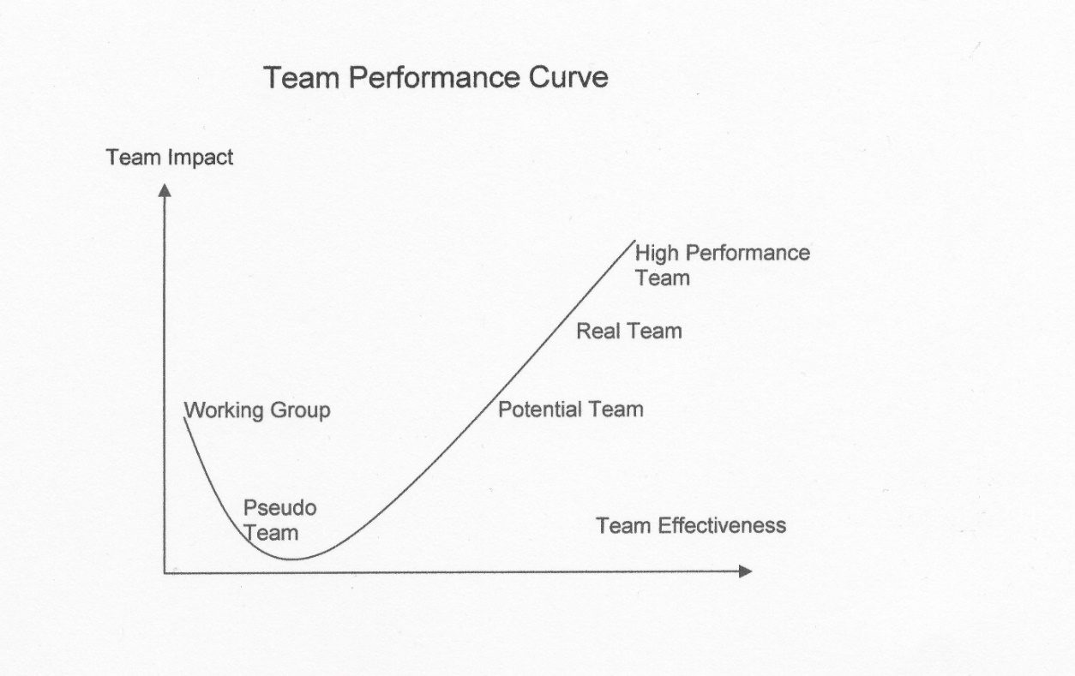

Sean Reflection Figure 1: Team Performance Curve For reference

**Team Performance – Problem 2 and how I addressed it.**

As the game became bigger and it became more difficult to think of new features to add, it became slightly more difficult as versions of the game became more complicated, new bugs had risen out of what seem like nowhere. It was quite hard to source the causes of bugs and issues and it was a more frustrating environment to work in. I started to notice slight hints of certain factors that could act as barriers to effective teamwork such as goals became slightly unclear. It was difficult to find one common goal for us to focus on at a given time, communication became less clear as we were all under pressure and didn’t have much time for meetings as more assignments came out and Games Fleadh approached. I did address the communication issue by sending out a message in our group chat, identifying the lack of communication, saying we need to address it and get back on track. It was very difficult to decide which version to work on or what to add/fix at the time. Communication resumed as normal and we managed to pull everything together for Games Fleadh which was a great success for us as a team and a good demonstration of how were able to adapt in a pressured environment and work on a common goal as a team to meet an important deadline. For example, myself and Joe met up in-person the day before Games Fleadh to work out some bugs in the game and get a plan of attack for the final night of bug fixing.

**Team Performance – Learning outcomes**

If I learned anything from the teamwork aspect of this project it would be to enforce more clear and obvious requirements for each member with stricter deadlines to ensure everyone has a clear directive and should someone fall down on a feature at least we can all come together as a team to work it out. While we did take this approach at the beginning, it became more difficult as the need to iron out many bugs had arisen extremely close to Games Fleadh. If I was to be part of a team project again, I would love to take the upon the role of Chairman/Team Leader as I believe I could do a better job, compared to times before I entered the team, at taking initiative and keeping the team on track should times get hard. I have always had a passion for team work but a fear of leadership but after this project I would feel a lot more confident taking on a leadership role in a group project so long as I understand what is required of the team and that the goal is achievable. Had I been in the role of chairperson I would have held more face-to-face team meetings as it encourages a more in-depth and dynamic conversation. It allows each member to express their opinions more clearly and allows them to articulate their questions and issues more easily. It also requires all members to engage fully in the conversation, whereas they may not if they are at home typing in a group chat. I strongly believe the ability to hear the tone of a person’s voice and reading their body language helps understand whatever is being discussed and there was not a lot of face-to-face meeting towards the end of the project when I believed we needed them.

**Conclusion**

Overall, the project was a unique experience, my knowledge of programming, from what I have done myself and what I have seen from the other members, has increased dramatically. I have a much better understanding and completely different view as to how I would go about tackling a team-based project. The experience gained from such a project, having learned from mistakes that actually happened and having seen alternative to things we had complete has yielded more knowledge to me than reading any number of books in my opinion. I am delighted how the project turned out, from where we started to what we have now. I must commend my teammates for their commitment and experience I have gained from them.

## Brian Ryan Reflection

This self-reflection will explain the role I played in the group project throughout the year. I will attempt to describe the part I played in the design and development of our 3rd year project. I aim to discuss the learning outcomes that I have achieved and my contribution to the team in the technical side of the project, the documentation deliverables and in project management.

This project module started in the summer of 2016 for myself and the guys. When we received emails from college advising us to think about groups and ideas for games we quickly formed a group and began working on ideas. Two of my peers would come to my house for a couple of hours once a week and we began working on brainstorming ideas and playing around with game concepts.

These early meetings were very beneficial, exciting and interesting to me. They were beneficial because I felt that we had been getting a head start on the rest of the class if you like so we had ideas out in the open and we had a sort of plan about what we wanted to do before some of our colleagues had even picked groups. Also, very beneficial because we were learning about idea generation techniques such as brainstorming, storyboarding and attribute listing. The meetings were exciting for me because it was the start of the first major project that I had undertaken and I soon realized the scope and the magnitude of what it was that we had to deliver, so I guess it was a nervous excitement but still excitement all the same. It was very interesting to see what ideas and concepts the two guys in the group had and what ideas we could come up with together.

These summer meetings were a great help to me in learning a lot about some different game engines also. We had not yet received the exact guidelines for our project from the college so over the summer I had been learning a lot about Unity game development and I completed quite a few Unity tutorials that are on the internet and on the Unity website. I learned a lot about the engine and how to create simple game scenes and simple games using Unity. I found out in September that unfortunately for our project we were not allowed to use a game engine, so my learning efforts over the summer could not be used for our project but I am sure that I will use these self-taught skills at a later point in life.

September came and we were back in college. Unfortunately, we lost 1 of our group members due to reasons beyond our control, so we had to recruit a new team member. We had our first group meeting and we set about arranging our roles within the group who would be chairperson, time keeper and scribe. During this meeting, we decided that each team member would go away and begin researching different programming languages and libraries to see what would be best suited for our project. It was at this point that we also had to deliver on our first document which was needed to satisfy the project requirements, the initial proposal document. We all worked on this document together equally and prepared it for delivery. I worked on some of the description needed and reasons for selecting the project.

I began studying and researching C++ with the SDL extension library. There are many resources available on the internet to assist in learning how to use SDL. I came across different vendors that provided video tutorials and written tutorials, all of which were good sources of learning and inspiration. Over a two or three week period the research and studying continued, every day new concepts were learned and valuable information was gathered from researching. The one tutorial series that helped and provided invaluable nuggets of information was [Lazy Foo’s SDL tutorials](http://lazyfoo.net/tutorials/SDL/index.php), these tutorials are invaluable and although they are only written tutorials and not video tutorials which sometimes are easier to follow, the lazy foo tutorials were easy to follow and understand.

I started to take a role in project management very seriously also at this point, I kept detailed notes of what every team member was doing, I set up our GITHUB account and started to make regular uploads of the teams work, tutorials and code snippets were kept for reference. I was always in contact with the guys keeping everyone posted of what was due and when and keeping track of our meeting minutes.

It was from the Lazy Foo tutorials that I realized we could get a prototype for our side scrolling racing game put together. I was working through all the tutorials and decided to take the scrolling background tutorial and make it work for our project. The code was easy enough to follow and understand. I put the code together and compiled it and soon had a working example of a window being displayed with a scrolling background. Essentially what the code was doing is rendering two iterations of the background image next to each other and simply moving them a little every frame. When the backgrounds have completely moved, we reset the motion and do it all over again. We manage to do this by setting a value to be the scrolling offset, this value is manipulated and checked against the width of the background image and reset when the backgrounds move off the screen.

Next was adding a moving object on top of this scrolling background, this object at first was a simple blackdot.png. This involved creating a class for the dot and giving it some parameters such as a width, height and velocity. Then I needed to create a handleEvent () function for key presses and a move () function which would move the dot across the screen, left or right and up or down. Also, a render () function to draw the dot to screen using SDL image. The handleEvent () function was set up so that there was a check to see if keys were pressed or if keys were released and then there was a switch statement case set up on each key to determine was it up, down, left or right and the velocity was set accordingly. The move () function was setting the position to increment or decrement per the given velocity coming from handleEvent (). The render () function would render the image on top of the scrolling background, which helps with the effect of the scrolling background.

We now had a moving dot on our scrolling background, all that was left to do was to swap out the background image for some art work of our level and the blackdot.png was to be swapped out for an image of our player’s ship, this artwork was supplied by Sean’s partner, many thanks to her. At this point in the project we essentially had a basic working prototype of the game up and running.

Up to this point we had already had some deliverable documents for our project which we all duly handed up on time and put large amounts of effort into. We had a presentation to do based around our formal proposal and a document to accompany this presentation, which was a technical proposal document. This again was quite a substantial document which we all took parts of and worked together to get completed, I also added in the team charter to this technical proposal document. We worked on the power point presentation together, each completing some slides to get the job done.

The next task I undertook as a technical task to help with the project was to try and get a timer incorporated into the game in some way, after all it was a racing game we were supposed to be making so some kind of a clock system or timer would be needed. The clock was obviously going to be a vital part of the game so I thought I would take a go at getting it implemented. I followed two different tutorials which were both using the SDL_GetTicks () function, this function returns the time since the program started in milliseconds. I was also trying to get a string with the time stored into a string stream using the #include <sstream> header at the top of the file. My theory using this string stream was that I could try and make the program read and write to a string in memory so that I could store the time in a string stream and then I could call on this string stream to render the time to a texture on screen. I tried for a long while to get things working how I wanted but to no avail, I was having some trouble storing the current time using SDL_GetTicks () to the string stream and then after days messing around with it I was double guessing myself there thinking that I was doing the wrong thing completely.

In the end after a week and a half or nearly two weeks I went back to my team mates and asked for some help and asked for a fresh pair of eyes on the problem, this helped, as Joe being Joe could see what was wrong within a few days when he got a chance to look. This was a great learning experience for me as I messed about with the SDL clock for a long time and although I never got it working correctly, I came very close to having it working exactly as I had planned and imagined, this was not a basic programming task, it was quite complex I believe and it will stand me well for the future.

By this point in the project we had our interim presentation completed and we had a change of project supervisor this was not an ideal situation but then it did give us an insight into what another lecturer thinks about how we were doing and where we were, in terms of tasks that needed to be completed, I think this was very beneficial to us as a group. Our project was also coming along nicely and was making huge leaps forwards at a very rapid pace, thanks to all the work that the guys had been doing, credit given where credit was due, the lads had done massive amounts of work by this point and were hard task masters to keep up with. But again, this was good for myself and the group to have this motivation it helped to keep myself motivated and keep the group on track. I was doing a lot of project management work at this point, keeping up with the GITHUB account, keeping the shared repository clean and organised. Liaising with my team mates to keep tasks on track and see what it was that every 1 was working on.

I soon started to play around with the idea of a main menu for the game, we needed a menu to navigate the player through the different options that we wanted to create for the game. I first drew out how I thought the menu would look and how I had imagined it being. The first iteration was very simple with a logo and four buttons underneath the logo, ‘New Game’, ‘Settings’, ‘High Score’, ‘Quit’, obviously, each button would have its own functionality.

This button functionality was based around mouse events, check to see if the mouse is moving, is the mouse button down or up? We check if the mouse is inside the area of the button then we go to the relevant switch statements checking each case and each button and carry out the required action. Creating the buttons was done by using a sprite and setting an enum value for the relevant buttons, the button text was rendered to the screen and the sprite enum for each button was handled. There was an issue with this menu when it was put together, the new windows were opening and all was ok in that sense but the new windows were non-responsive, the X button in the top right of the windows was not working at all, for example. These new windows had been created by using the same init () function as the main game window.

This version of the menu was radically overhauled in a later version of the game when a finite state machine was introduced by Joe, this made the menu a lot more responsive and fit for purpose. There was a steep learning curve throughout this project and every step of the way new nuggets of information were being learned in a collaborative environment which was very beneficial and will stand by me long into the future.

The story screens were next on the agenda, coming up with a storyline in-between each level, something to keep the player amused and entertained. This was a collaborative effort and the story took a few different avenues before it became the finished product. However, it got there in the end and I believe it is a good little story for what it is, not many racing games as such give the player a story so I think this was a valid selling point for our game, it was different and unique. That whole part of the project, trying to be unique and different was very important to all team members from the very beginning and something which I think we all embraced.

High score table and screen was another challenge that I faced into as part of the project, this took me a little while to grasp, exactly what it was that was needed and then to implement it the way we wanted. Firstly, we decided that for games fleadh and the group project we did not need a database at the back end of the game to store high scores, we decided on a simple text file being created and high scores being saved to the file and read back from the file when called upon. Great learning was had during this task as I had to go back to basics with C++ and learn reading and writing to and from a file and then had to incorporate the text being read back in from the file as a rendered text image using SDL. I first made a simple program writing to and reading from a file. Incorporating this into the game at first was a little tricky but I figured out that at the end of the game where the players score was saved into a variable for displaying on screen, it was at this point I would create the file and write the scores to it. When a user was to hit the high score button the scores would be read from the file and rendered to a text image that could be displayed. I was using the getline () function in a while loop to read the text from the file into a rendered text function that Joe had already created for other parts of the game. However, this getline () was not doing what I needed it was not reading white spaces or every word on the line, it would stop when it got to a whitespace. I figured this out because of all the times I tested it and with different variations of the text to read from the file. In the end, it was made so that it read 1 word, went to the next line, read another word, go to next line and so on. This was a good learning experience for me as I spent a lot of time fiddling with different outputs for the text from the file and vice versa, I spent a lot of time checking how to format the text into the file.

The final documentation task was quite substantial and a lot of work has gone into it from all team members, it has been a great exercise in documentation and in keeping notes as you work. I think we all kept notes thorough the semester to make sure we had some point of reference for this final document and it has helped greatly in putting the document together.

This project has been a massive learning experience and some great knowledge has been gleaned from the whole adventure, I like to think of it as an adventure that we took together and came out the other side of together. I am sure this will stick with us all for life.

All in all, the project went very well, we came together at the start and a lot of work was done in a short space of time. The team was working well together and got on well together. We communicated well and the project surpassed all our expectations, I believe this is because of the team work we produced.

There were times when we may have been tired of it and had enough of it, I know myself personally my performance slipped off the slope a little towards the end, it’s not something to be proud of at all, but a valuable lesson learned in team performance. It is not over until it’s over no matter how tired of it one might be, we must keep going as a team and persevere together until the very end.

I do believe that I have the skills to work well in a team and get a team to work well together. I think I have all the qualities of a good leader and that I have an uncanny ability of getting people to work together towards a common goal. I would never criticise someone’s ability or lack thereof and I would always try to motivate team members and keep them all happy. I firmly believe that a happy team is a productive team.

## Test Cases

Additional unit testing and additional feature testing carried out show the evolution of the game over time to the current version shown in **Figure_79**. The resolution of the screen progressed from 640 x 480 to 800 x 600, and finally 1280 x 720 as more features were added, and we needed more screen space to display it all.

**Figure_80** Shows testing of basic collisions between objects. **Figure_81** shows testing of the game timer, working with True Type Fonts caused a lot of headaches, but as soon as we got it working we could add the timer, level number, and other game text. **Figure_82** shows testing of the scrolling background. Having the scrolling background stop at the end of the level where the Enemy Boss would be located seemed look like a good idea, and wasn’t too difficult to implement.

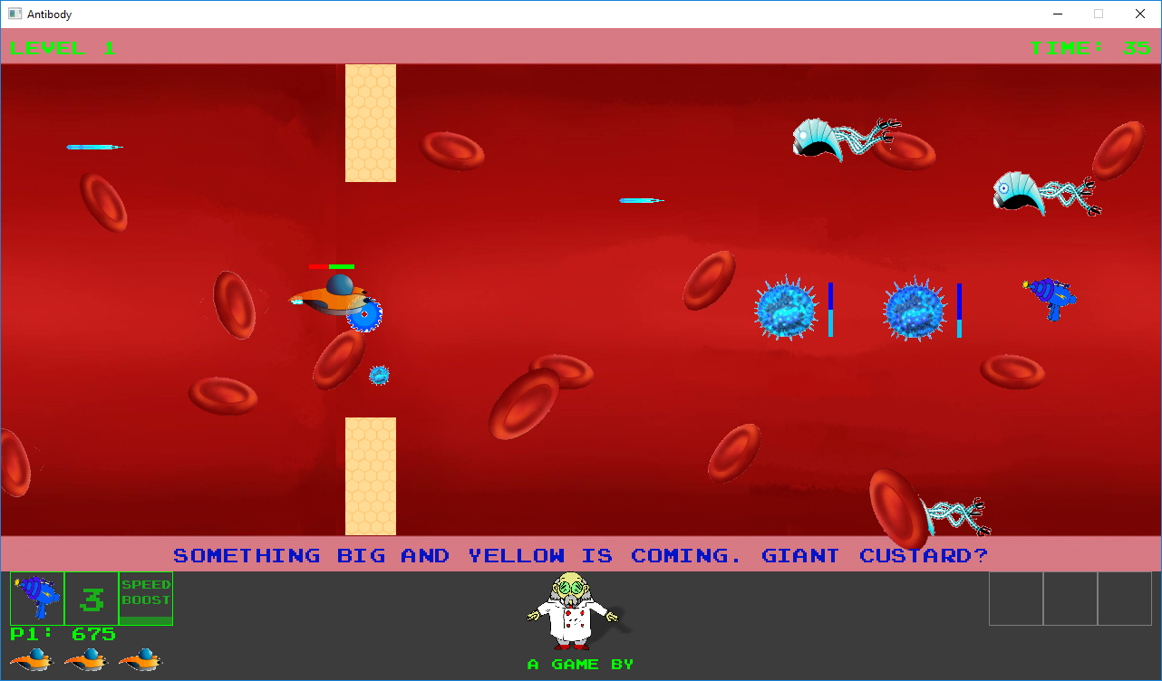

Figure 79 Collision Testing: Player Cutting Through Blockage with Saw

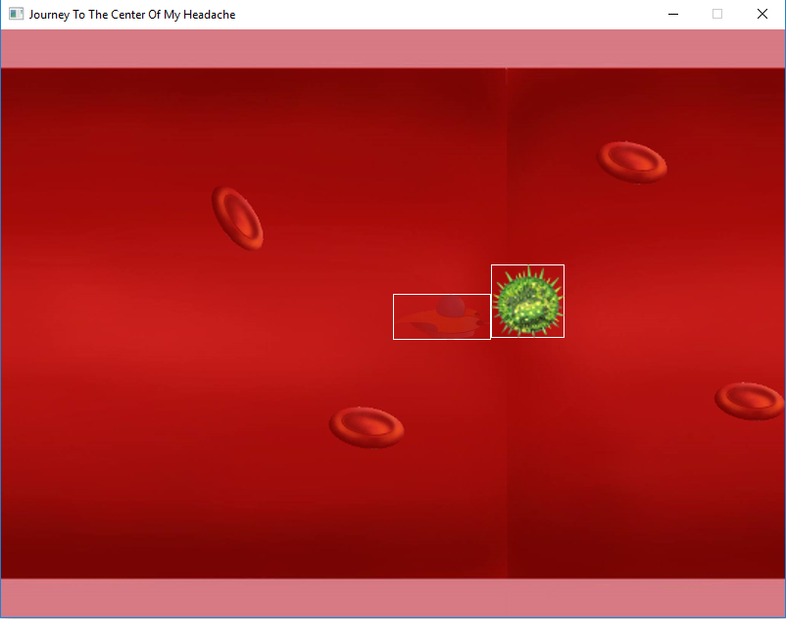

Figure 80 Collision Unit Testing, Player ship flashes after colliding with a static object

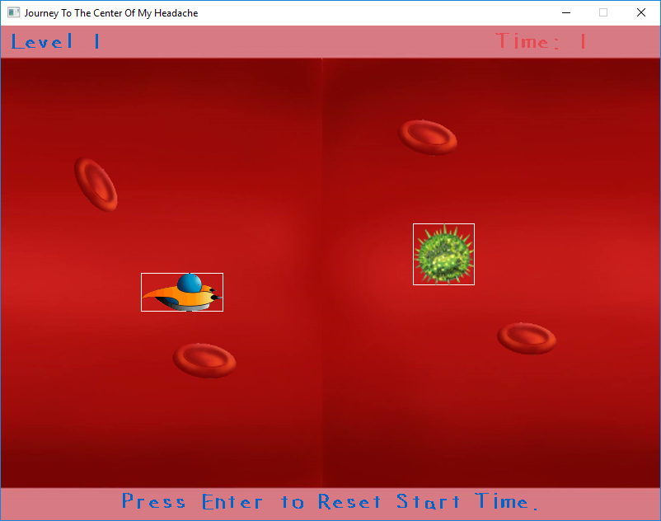

Figure 81 Timer Unit Testing: The timer flashes when time is running out

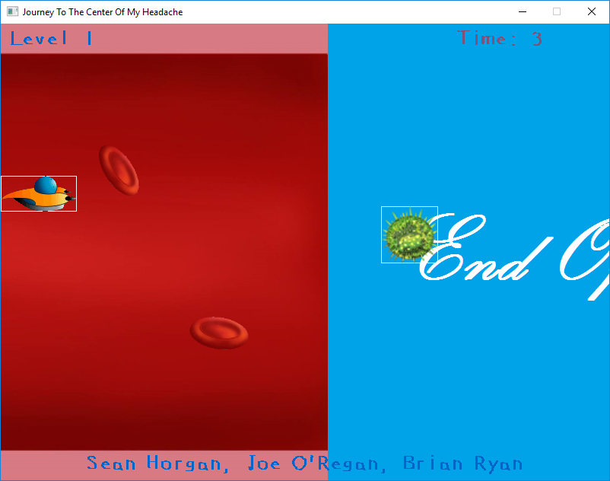

Figure 82 Background Unit Test: Background stops scrolling after a fixed number of frames

**11.5 Game Installation**

**Installing the Game**

The game was created with Visual Studio Community 2015 and requires this to run. This is available to download free from <https://www.microsoft.com/en-ie/download/details.aspx?id=48146>

The game also requires SDL libraries SDL_2_Image, SDL_2_Mixer, and SDL_2_TTF, for images other than bitmap, using audio, and using true type fonts respectively.

Library directories are linked to the project by selecting Project > Properties > VC++ Directories and setting the path to the Include Directories (**Figure_83**) and Library Directories. For this version of the game we are not using any SubSystem under the Linker > System tab.

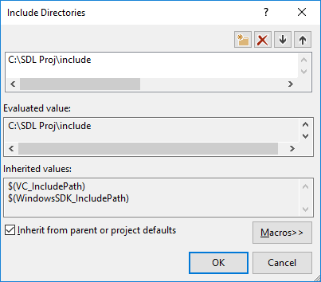The uploaded version of the game uses the path C:/SDL Proj/. This is the universal setup configuration all group member used during the coding and testing of the project. The SDL Proj folder is included with the code listings on the included DVD.

Figure 83 The SDL Include folder path must be added to the project, the same for the Library folder

**11.6 How to Play**

**Playing the Game**

**Objective**:

Racing against the clock the Player must reach the end of each level before the timer runs out. Avoiding enemies and obstacles and destroying these where possible.

**Level 1:** Destroy the Enemy Virus, split them into smaller pieces so the Professors White Blood Cells can deal with them, avoid detection by Nano-bots, and destroy if possible.

Avoid destroying vital Red Blood Cells, these are critical to the health of the professor. Reach the end of the level, collect Power Ups, and watch out for checkpoint timers to increase the necessary time to complete the level. Then battle the end of level boss.

**Level 2:** Avoid obstacles, and other enemies, while also racing against the clock. Obstacles can push the player out of range, damaging the Players ship.

**Level 3:** Battle an increasing range of enemies.

**11.7 Game Controls**

**Controls**

The game uses the keyboard as the main input device. **Figure 84** shows the layout of the keyboard. Green represents general game buttons, red Player 1 controls, and blue Player 2 controls. Further details are included in tables **6, 7 & 8.**

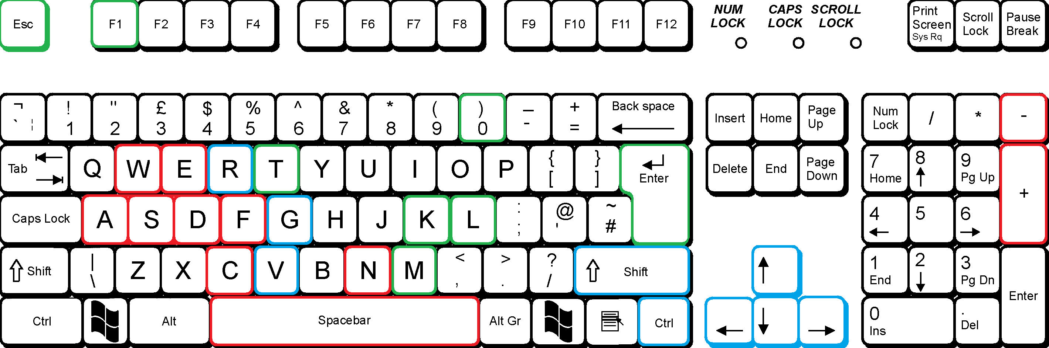

Figure 84 Keyboard Control Layout

|  |  |
| --- | --- |
| **Table 6: Player 1 Keyboard Controls** | |
| **A** | Move left |
| **S** | Move Down |
| **D** | Move Right |
| **W** | Move Up |
| **E** | Activate / Deactivate Saw. When Saw is active, shield is deactivated, and vice versa |
| **F** | Activate Speed boost, time remaining will be indicated by status bar in heads up display. Speed boost will be active for 3.0 seconds |
| **C** | Pressing C activates the rocket and rocket status bar for power. Releasing the button fires the rocket. If the button is not released before the status bar has finished, the rocket will be destroyed. A rocket will generate a higher score, which will be indicated to the player as an onscreen message if they successfully steer the rocket towards its target |
| - | Moves the rocket up the screen (decreases Y axis value) |
| **+** | Moves the rocket down the screen (increases Y axis value) |
| **SPACEBAR** | Fires the laser weapon |
| **N** | Fires ninja star weapon |

|  |  |
| --- | --- |
| **Table 7: Player 2 Keyboard Controls** | |
| 🡨 | Move left |
| ↓ | Move Down |
| 🡪 | Move Right |
| **↑** | Move Up |
| **R** | Activate / Deactivate Saw. When Saw active shield is deactivated, and vice versa |
| **G** | Activate Speed boost, time remaining will be indicated by status bar in heads up display. Speed boost will be active for 3.0 seconds |
| **V** | Pressing C activates the rocket and rocket status bar for power. Releasing the button fires the rocket. If the button is not released before the status bar has finished, the rocket will be destroyed. A rocket will generate a higher score, which will be indicated to the player as an onscreen message if they successfully steer the rocket towards its target |
| **-** | Moves the rocket up the screen (decreases Y axis value) |
| **+** | Moves the rocket down the screen (increases Y axis value) |
| **CRTL** | Fires the laser weapon |
| **SHIFT** | Fires ninja star weapon |

|  |  |
| --- | --- |
| **Table 8: Other Game Keys** | |
| **Esc** | Pause / Main menu or back to menu from sub menu |
| **F1** | Show Frames Per Second |
| **T** | Show / Hide the Game Map |
| **0** | Stop the music |
| **K** | Skip music track backwards |
| **L** | Skip music track forwards |
| **M** | Pause the music track |
| **ENTER** | Enter text from Enter Name screen |

**Gamepad Controls**

The game can also be controlled with a game controller Figures **85 & 86** show the layout for controller buttons.

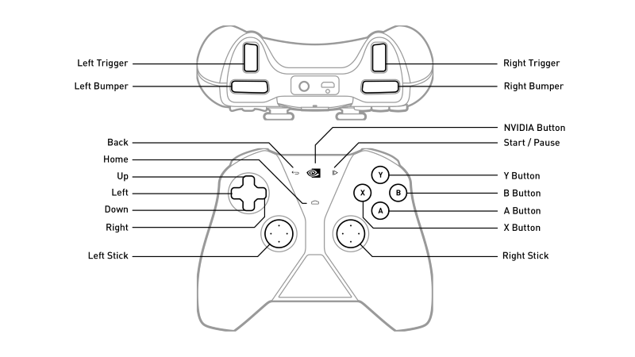

Figure 85 Button layout for NVIDIA Shield Controller

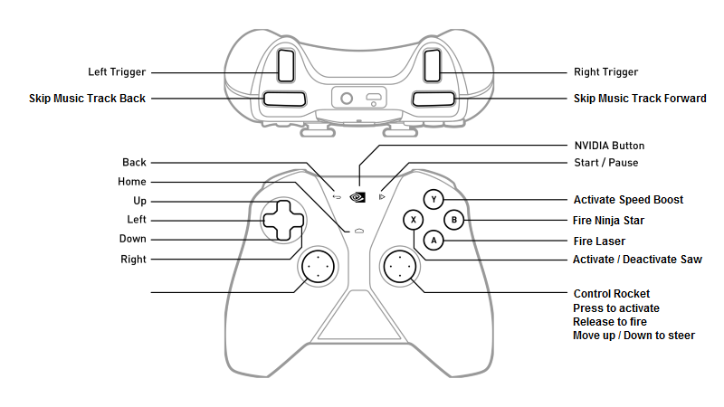

Figure 86 What the buttons do in the game

**11. 8 Team Charter**

**Team Charter**

**Purpose & Goals**

This team has been tasked with making a racing game developed in C++ as part of our 3rd year Group Project module in our Bachelor’s Degree.

We must have a common goal between us which is to achieve excellence through good group coordination, collaboration, understanding and personal growth. Whilst using all the resources at our disposal we must achieve the highest level of academic performance.

We must be committed to working effectively as a team by consistently evaluating our tasks and our performance in these tasks. Our overall goal must be to demonstrate excellence in our final presentation and report.

**Team Management**

**Meetings:** Each team member must agree to meet each other for a dedicated meeting time at least once a week for a minimum of 30 mins and a maximum of 1 hour. Where we will discuss what, we have been doing over the previous week and what we intend to do over the coming week.

Each meeting will have the same guidelines and each team member is expected to follow and adhere to these guidelines.

Purpose of meeting; Identify the point of the meeting, everyone involved must agree on deliverables for each meeting.

Agenda; We must identify the topics to be discussed and agree upon an allotted time to discuss each topic.

Code of Conduct;

* Attendance for each meeting is mandatory unless prior notice has been given with a genuine valid reason as to why one can’t attend
* Arrive on time
* Stick to the Agenda
* One person speaks at a time

Expectations; High expectations are set for each and every member of the group and these levels of expectancy are set out at the beginning of every meeting

**Team Communication:** As a team, we will communicate with each other in various ways. We will have a group chat session running in Google Hangouts at all time throughout this project. We will be in constant communication every day through this means of conversation. We will see each other every day in college but we are not to sacrifice the time meant for other modules on the group project. If the need arrives for discussion it can be done on breaks or in between lectures. We all have each other’s mobile number and email address if we need to make contact that way.

|  |  |  |
| --- | --- | --- |
| **TEAM MEMBER** | **EMAIL ADDRESS** | **MOBILE NUMBER** |
| Joe O’Regan | k00203642@student.lit.ie | 0876660504 |
| Sean Horgan | schorgan2@gmail.com | 0879464429 |
| Brian Ryan | bpryan1@gmail.com | 0831992231 |

Prompt responses to queries and messages between group members is expected by everyone involved.

We have a shared workspace on Google drive where we will collaborate all work done. All work done by each group member must be posted to the shared drive space as soon as completed and a message sent to each member of the group to notify them of the post made.

Any code listings we are working on must be committed to the shared GitHub account we have set up for the group project. Again, any committals made to GitHub should also be notified to each group member.

**Decision Making:** Open and honest discussions must be held in relation to all decisions during the project. If anyone feels they have an important point to make or a suggestion which should be heard, then all group member’s must listen and treat each opinion with courtesy and respect. If we as a group cannot reach agreement about a certain point or decision which needs to be made then we will hold a vote, a simple 2 to 1 majority vote wins, result of the vote must be accepted and respected by all members. If we as a group cannot come to agreement on certain aspects, then we may have to enter a further round of discussions and each member is expected to bring facts to the table to support their suggestion or arguments.

**Participation:** Each group member is expected to participate fully in all activities that the group undertake. Each member is expected to contribute fully to the project and bring some expertise to the project. If members feel that other members are not partaking in the project 100% then something must be said and a discussion must be held in relation to getting the violating member up to speed on the workload.

Each member must sign this charter and agree to its terms and conditions laid out

Joe O’Regan . . . . . . . . . . . . . . . . . . . . Joe O’Regan

Sean Horgan. . . . . . . . . . . . . . . . . . . . Sean Horgan

Brian Ryan. . . . . . . . . . . . . . . . . . . . . . Brian Ryan

**11. 9 Original Feature List**

**Features list**

1. **Movement**: Player must be able to move throughout the levels. Control

initially by keyboard.

**Sub feature:** Add game controller, or steering wheel input

1. **Perspective**: Top down perspective

**3. Enemy Spawning**: Enemies can spawn at random points, or fixed points depending on the situation, level or stage of the level

**4. Player Weapons**: Player must be able to shoot enemies

**5. Power Ups:** Player can get power ups (speed, defense, attack, alternate

weapons)

**6. Collision:** Collision detection, contact detection

**7. Sound**: Add music, sound effects

**8. Graphics**: Sprites, backgrounds, and background layers for parallax, other

objects

**9. Timer**: Countdown clock, checkpoints, or time-stages

**10. Background:** Parallax Movement

**11. Personality**: Different player sprite (vehicle, car, ship), different colours representing different personalities, same for enemies, e.g. Pac-man

**12. Levels**: Adding difficulty as levels progress, increased number of and additional enemies. Different and less frequent power ups. Different objectives. Different backgrounds, and scenery. Alter the perspective, maybe change from top-down to side-view

**13. User interface**: Scores, time, menu, map, hints, dialogue, lives, health, weapons, inventory

**14. Enemy**: Implement a variety of enemies, some that are visible on screen at the same time, and some that only appear in the game at different stages, such as end of level bosses

**15. AI**: Artificial Intelligence for computer controlled enemy to race

against

**16. Multiplayer**: 2nd player to race against, one player representing the hero, the other the enemy, or a rival team

**17. Network Play**: Play multiplayer over a network

**18**. **Game Physics:** Force, velocity, torque, increase / decrease object speed.

**11. 10 Project Code DVD**

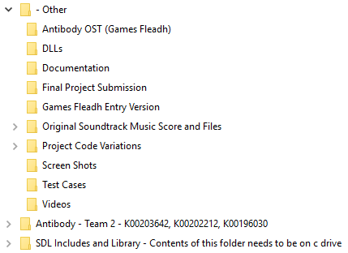

Figure 87 DVD Folder Structure

The enclosed DVD includes over 150 previous versions of the project as it evolved from our original presentation Demo. The Games Fleadh award winning entry version is included in “~\- Other\Games Fleadh Entry Version\” and the main project submission is included in “~\AntiBody – Team 2 – K00203642, K00202212, K00196030\”.

The SDL include and Library structure for the projects uses the folder structure “C:\SDL Proj\”. This folder is contained in “~\SDL Includes and Library – Contents of this folder needs to be on c drive\”. This folder can be just copied to the C drive on a computer running Visual Studio 2015 to launch the projects. WinRar was used to compress the project folders as .rar files.